

**NETWORKING & SYSTEM ADMINISTRATION LAB**

**Experiment No.: 1**

**Aim**

Familiarization of Hardware Components in a Computer.

**Procedure**

* **Motherboard**

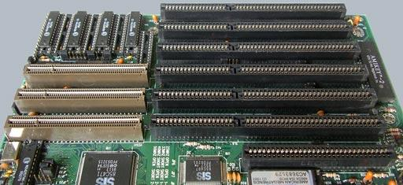

A motherboard provides connectivity between the hardware components of a computer, like the processor (CPU), memory (RAM), hard drive, and video card. There are multiple types of motherboards, designed to fit different types and sizes of computers.

Each type of motherboard is designed to work with specific types of processors and memory, so they don't work with every processor and type of memory. However, hard drives are mostly universal and work with the majority of motherboards, regardless of the type or brand.

* **NIC(Network Interface Card)**

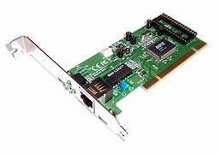

Short for network interface card, the NIC is also referred to as an Ethernet card and network adapter.A NIC is a computer expansion card for connecting to a network (e.g., home network or Internet) using an Ethernet cable with an RJ-45 connector.

* **Random Access Memory**

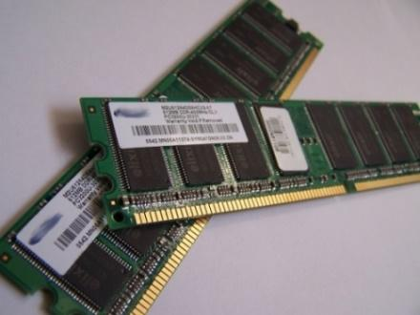

Random access memory (RAM) is fast-access memory that is cleared when the computer is power-down. RAM attaches directly to the motherboard, and is used to store programs that are currently running. RAM is a set of integrated circuits that allow the stored data to be accessed in any order (why it is called random). There are many different types of RAM. Distinctions between these different types include: writable vs. read-only, static vs. dynamic, volatile vs. non-volatile, etc.

* **Hard Disk Drive**

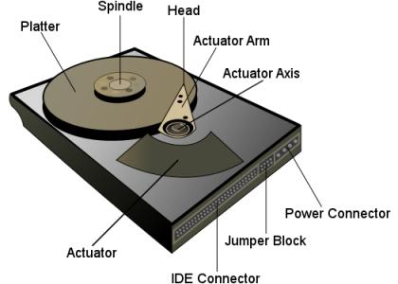

A hard disk drive (HDD) is a non-volatile storage device which stores digitally encoded data on rapidly rotating platters with magnetic surfaces. Just about every new computer comes with a hard disk these days unless it comes with a new solid-state drive. Typical desktop hard disk drives store between 120 and 400GB, rotate at 7,200 rpm, and have a madia transfer rate of 1 Gbit/s or higher. Hard disk drives are accessed over one of a number of bus types, including parallel ATA(also called IDE), Serial ATA (SATA), SCSI, Serial Attached SCSI, and Fibre Channel.

**Processor**

The processor, also called the microprocessor or CPU (for *Central Processing Unit*), is the brain of the PC. It performs all general computing tasks and coordinates tasks done by memory, video, disk storage, and other system components. The CPU is a very complex chip that resides directly on the motherboard of most PCs, but may sometimes reside on a daughtercard that connects to the motherboard via a dedicated specialized slot.

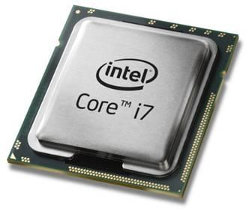

* **Heat sink.**

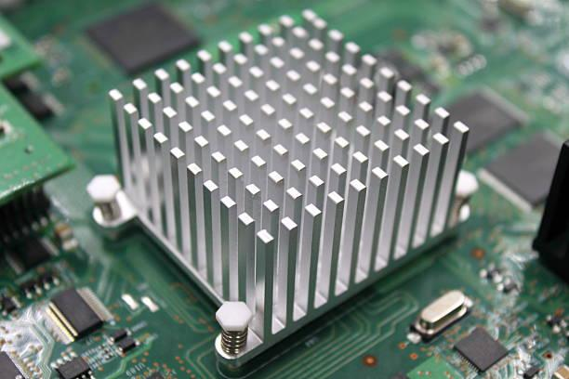

This is a passive piece of hardware that draws heat away from components to regulate/reduce their temperature to help ensure they continue to function properly. Typically, a heat sink is installed directly atop the CPU, which produces the most heat among internal components.

* **ROM Memory**

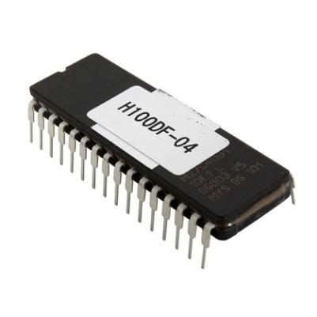

ROM stands for a type of memory chip that can be read from but not written to.

In other words, it's a form of data storage that can't be changed after being programmed.

It's sometimes called "non-volatile" memory because the stored information will remain even when not powered up or in use.

ROM is often used to store a computer's basic start-up instructions and certain types of data, such as your car's onboard computer system and a calculator's data tables.

* **Optical Drive**

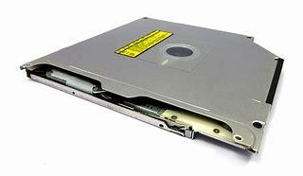

Optical Drives are used in PCs to read and write CDs and DVDs.

The optical drive reads the data from the disc, which can then be transformed into a digital file that is readable by the computer.

This makes it easy to backup files, play music or movies, or copy data from one disc to another.

The term "CD" refers to Compact Discs, which are the most common type of optical drive on modern computers.

* **Power Supply**

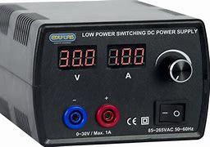

A power supply is an electrical appliance that provides the necessary power to operate a computer.Computers are powered by electricity, and the power supply converts the alternating current (AC) from the electric outlet into direct current (DC).The power supply in a computer can be an internal or external component.It’s important to make sure your power supply is functioning properly.

* **Graphics Processing Unit (GPU)**

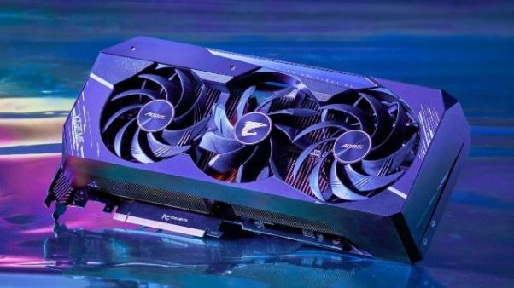

The graphics processing unit, or GPU, has become one of the most important types of computing technology, both for personal and business computing. Designed for parallel processing, the GPU is used in a wide range of applications, including graphics and video rendering. Although they’re best known for their capabilities in gaming, GPUs are becoming more popular for use in creative production and artificial intelligence (AI).

* **Solid State Drive (SSD)**

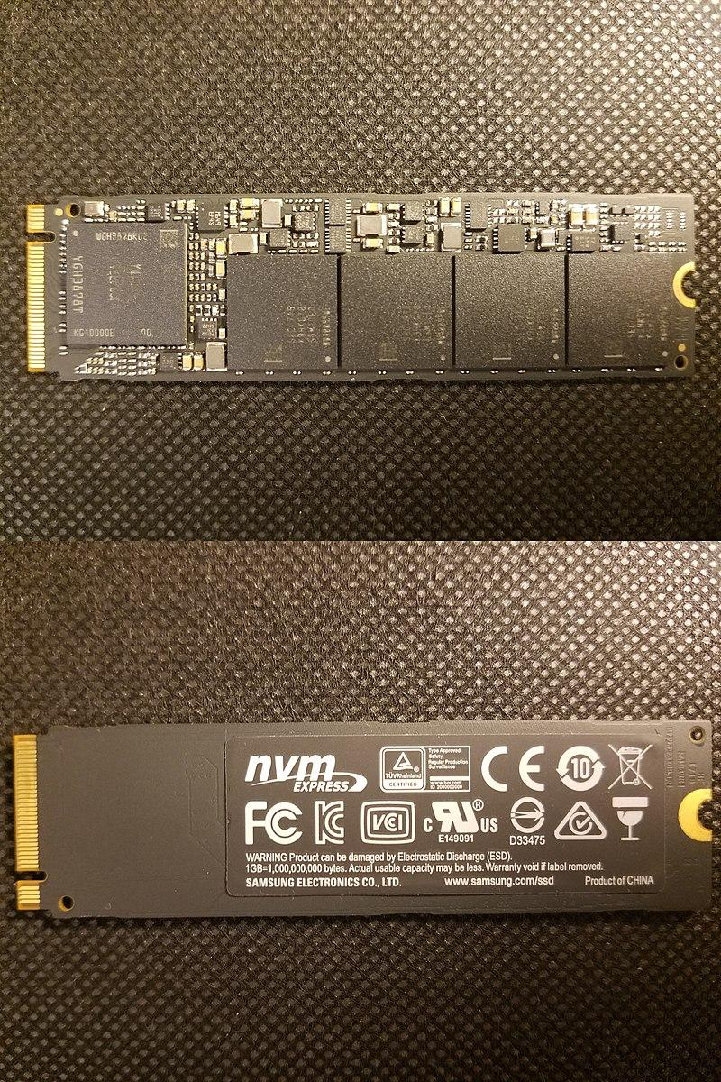

A solid-state drive (SSD) is a new generation of storage device used in computers. SSDs use flash-based memory, which is much faster than a traditional mechanical hard disk. Upgrading to an SSD is one of the best ways to speed up your computer. Learn how SSDs work and how to keep them optimized with a specialized performance-boosting tool.

**Experiment No.: 2**

**Aim**

Install the latest version of Ubuntu on an Oracle VM VirtualBox.

**Procedure**

**Step 1:** Install VirtualBox, then click "Next".

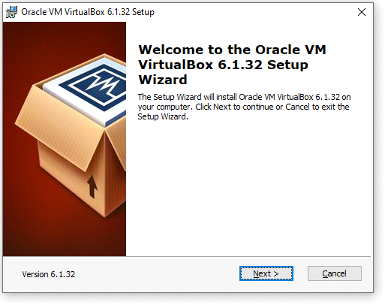

**Step 2:** Select features.

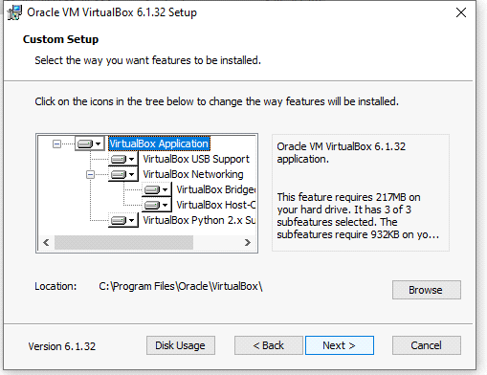

**Step 3:** Choose the options.

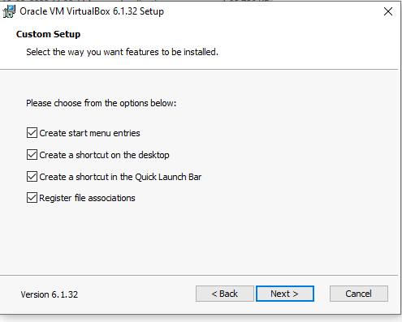

**Step 4:** Proceeding installation.

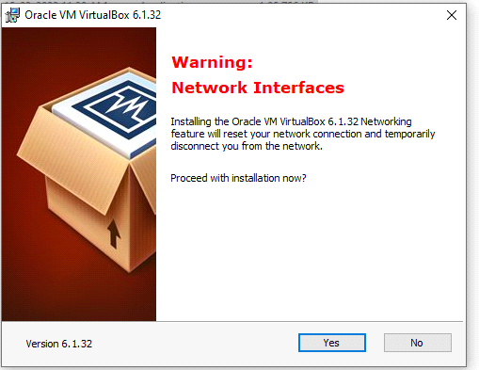

**Step 5:** Ready to install.

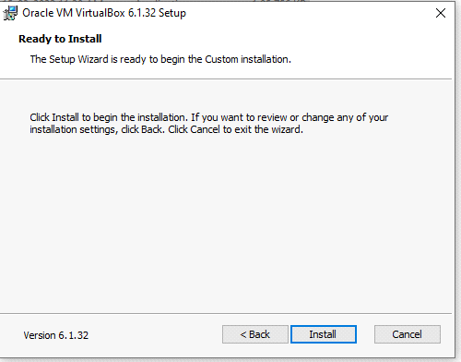

**Step 6:** Installing the Oracle vm virtualBox.

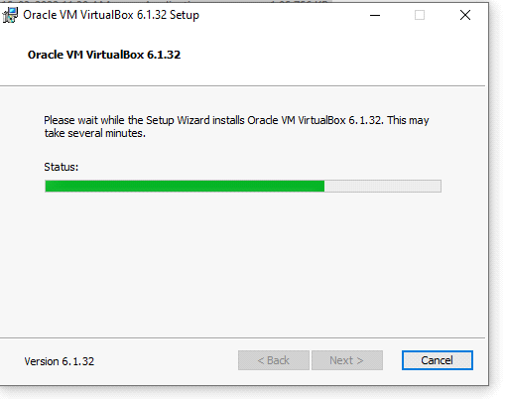

**Step 7:** Installation finished.

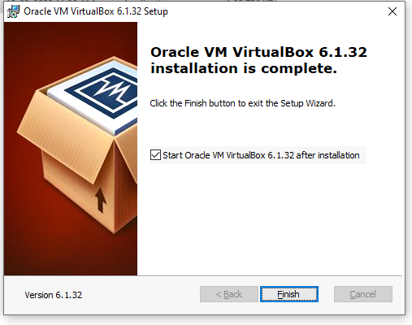

**Step 8:** Open VirtualBox, then click "New" to create a virtual machine.

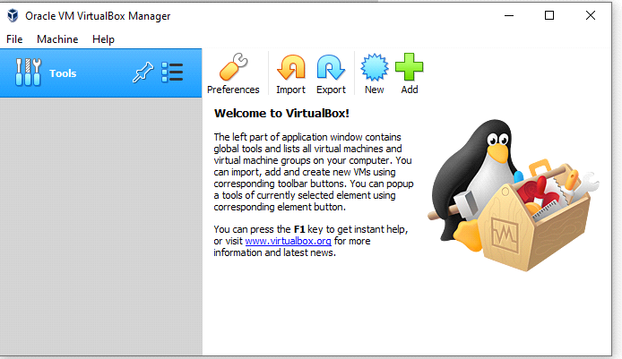

**Step 9:** Enter "Ubuntu" as the name, select "Linux" as the type, and select Ubuntu (64-bit) as the version. Select any amount of memory you wish, but don't add more than 50 percent of your total RAM.

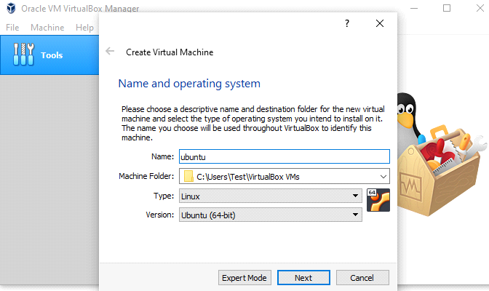

**Step 10:** We want to specify Memory size.

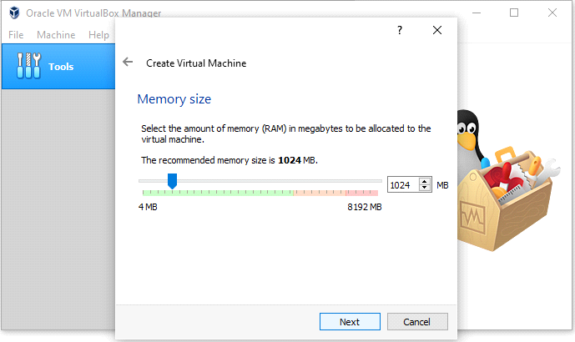

**Step 11:** Check the "Create a virtual hard disk now" option so we can later define our Ubuntu OS virtual hard disk size.

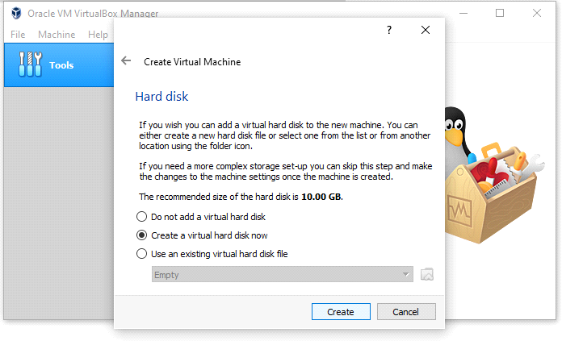

**Step 12:** Now, we want to select "VHD (Virtual Hard Disk)".

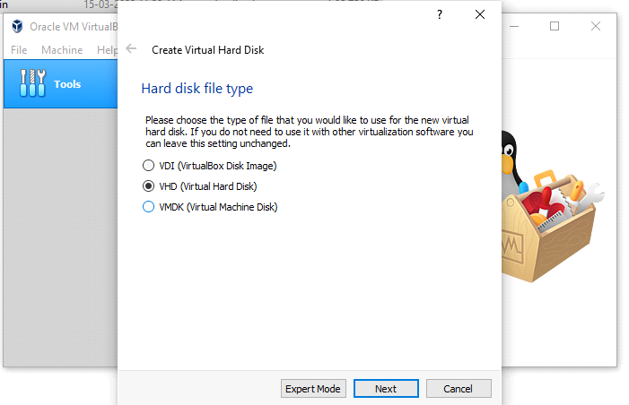

**Step 13:** Next, we'll dynamically allocate storage on our physical hard disk.

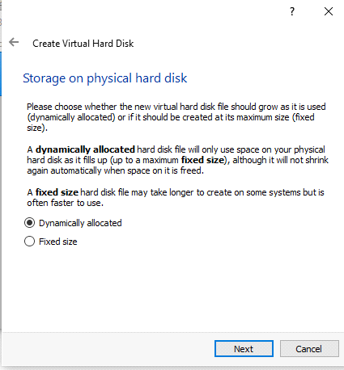

**Step 14:** We want to specify our Ubuntu OS's size. The recommended size is 10 GB, butyou can increase the size if you wish.

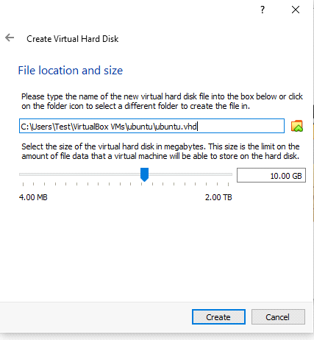

**Step 15:** After creating a virtual hard disk, you'll see Ubuntu in your dashboard.

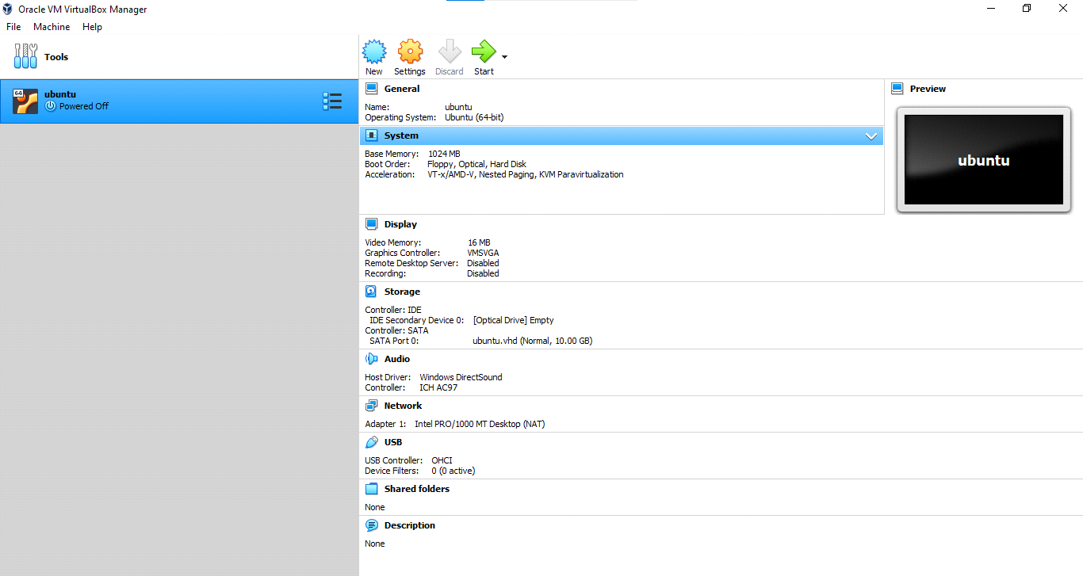

**Step 16:** Now, we have to set up the Ubuntu disk image file (.iso).

The Ubuntu disk image file can be downloaded here: [Ubuntu OS download](https://ubuntu.com/#download)

To set up the Ubuntu disk image file, go to settings and follow these steps:Click "Storage".

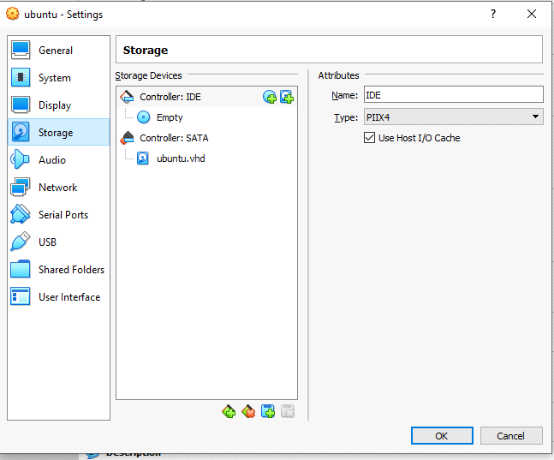

**Step 17:** In storage devices, click "Empty", then click the disk image and "Choose Virtual Optical Disk File" and Select the Ubuntu disk image file and open it. Click OK. Your Ubuntu OS is ready to install in VirtualBox. Let's start!

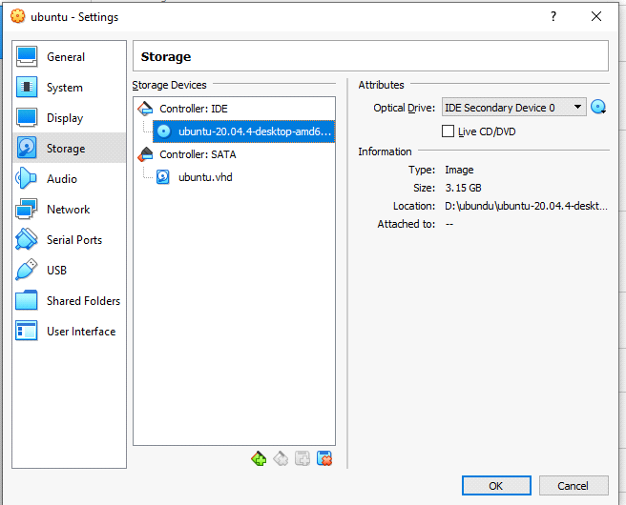

**Step 18:** Click Install Ubuntu.

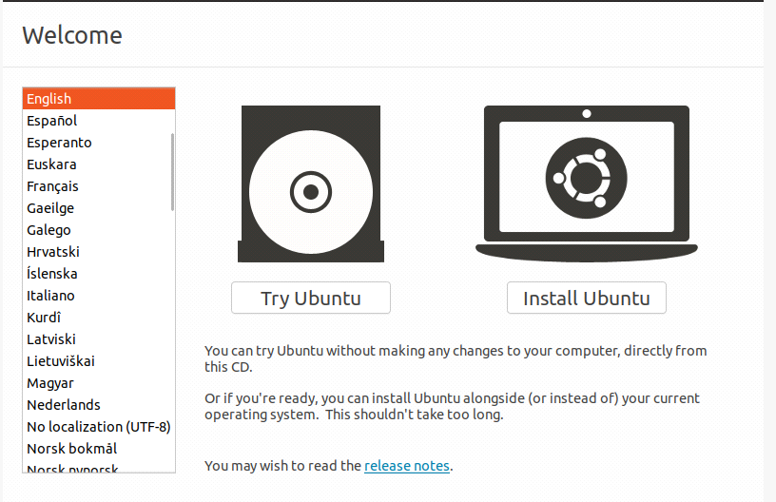

**Step 19:** Select your keyboard layout.

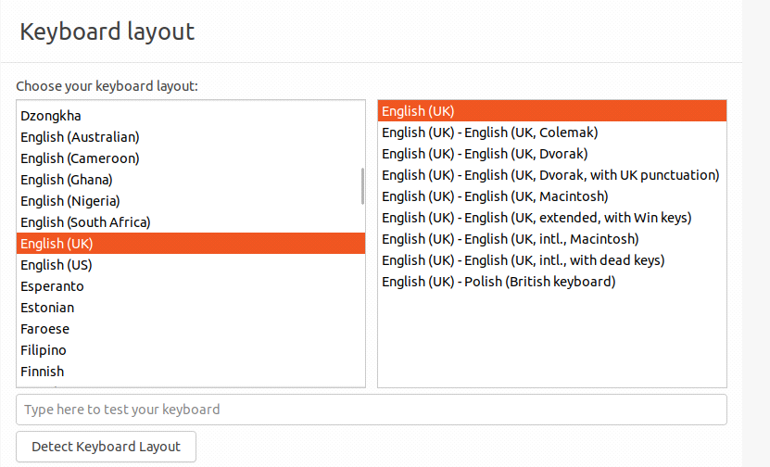

**Step 20:** In the "Updates and other software" section, check "Normal installation" and continue.

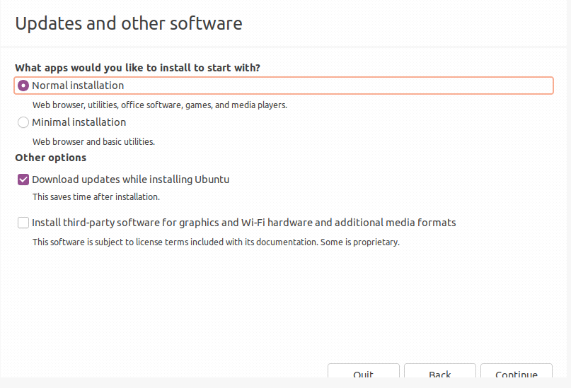

**Step 21:** In "Installation type", check "Erase disk and install Ubuntu"and Click "Continue".

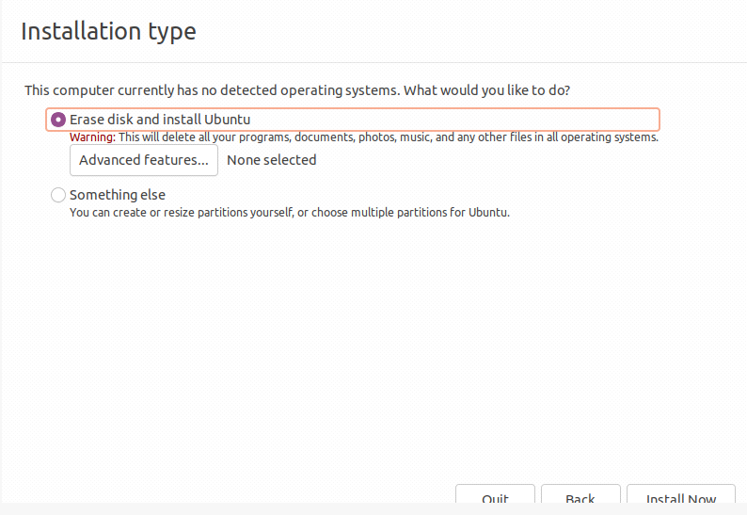

**Step 22:** Now, set up your profile.

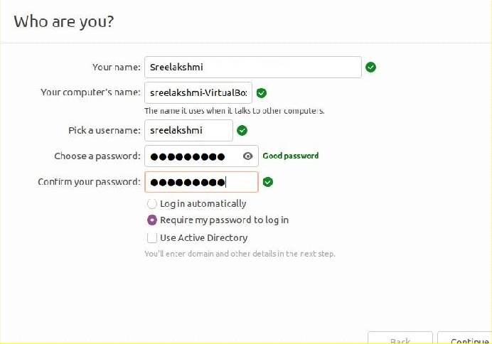

**Step 23:** You'll see Ubuntu installing.

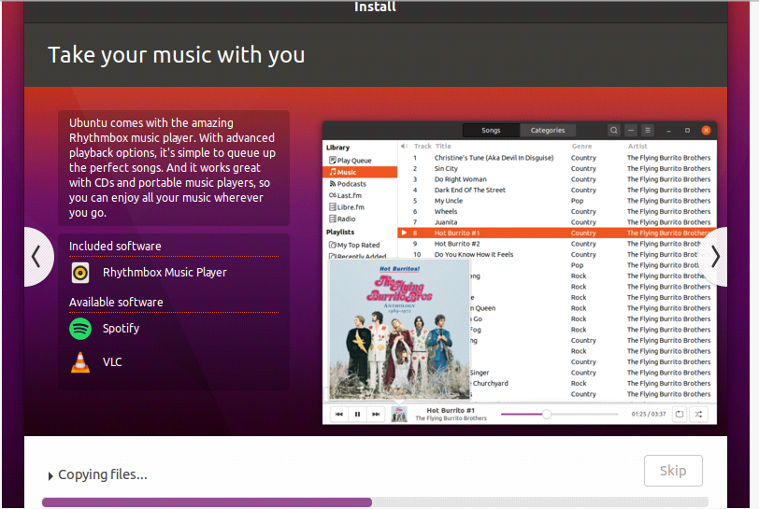

**Step 24:** After the installation, restart it.

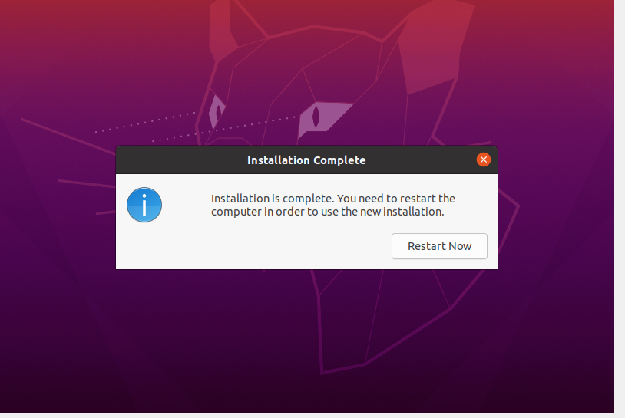

**Step 25:** After logging in, you'll see the Ubuntu desktop.

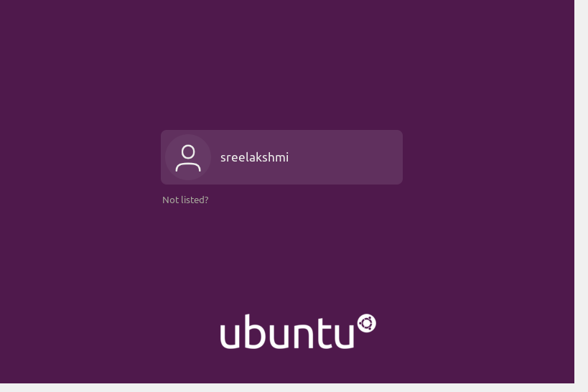

**Step 27:**

We have successfully installed Ubuntu in VirtualBox. It's ready to use for your future development projects.

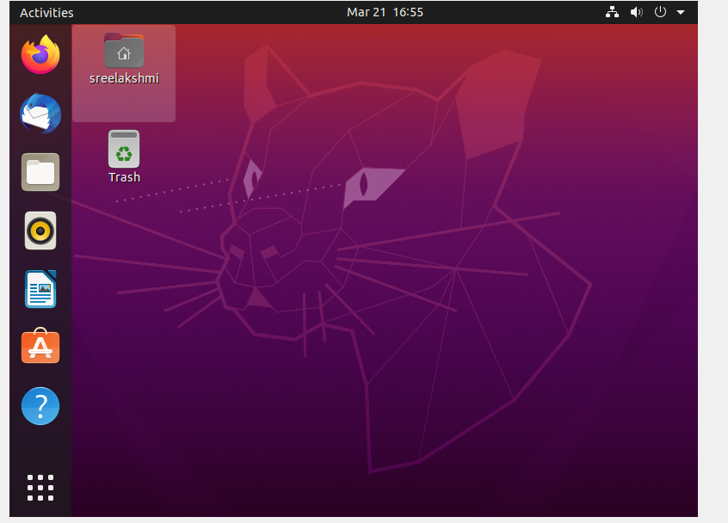



**Experiment No.: 3**

**Aim**

Familiarization of the linux commands.

**Procedure**

**1.pwd**

This command is used to display the location of the current working directory.

Syntax :- $ pwd

Output :-

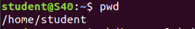

**2. mkdir**

This command is used to create a new directory under any directory.

Syntax :- $ mkdir<directory name>

Output :-

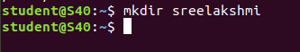

**3. ls**

This command is used to display a list of content of directory.

Syntax :- $ ls

Output :-

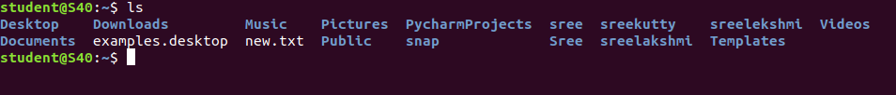

**4. man**

This command is used to display the user manual of any command that we can run on the terminal.

Syntax :- $ man <command name>

Output :-



**5. ls –l**

This command is used to shows file or directory, size, modified date and time, file or folder name and owner of the file, and its permission.

Syntax :- $ ls –l

Output:-

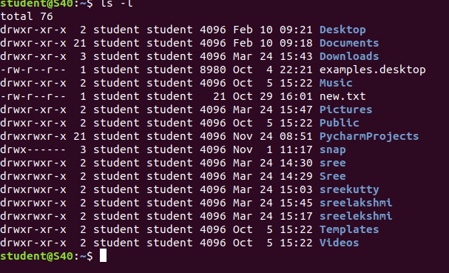

**6. ls –r**

This command is used to display files and directories in reverse order.

Syntax :- $ls –r

Output :-

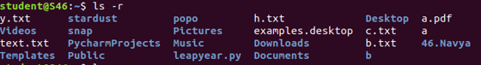

**7. ls –a**

This command is used to list all files including hidden files.

Syntax :- $ls –a

Output :- 

**8. ls –al**

This command is used to

Syntax :- $ ls -al

Output :-

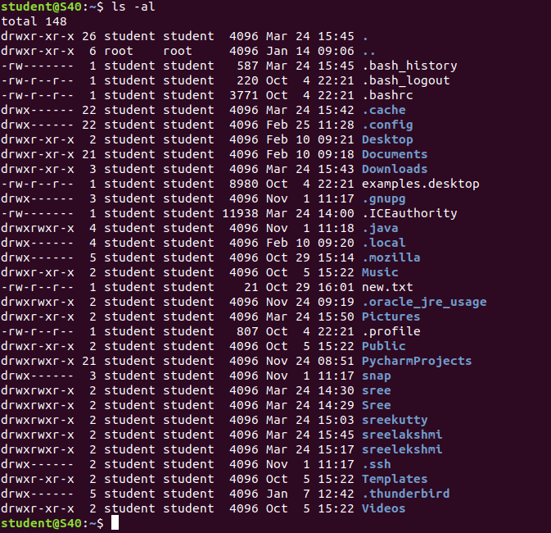

**9. ls –t**

This command is used to display files in the last modified order.

Syntax :- $ ls –t

Output :-

**10. cd**

This command is used to change the current directory.

Syntax :- $ cd <directory name>

Output :-



**11. cd ..**

This command is used to move to the parent directory of current directory, or the directory one level up from the current directory.

Syntax :- $ cd ..

Output :-



**12. cd –**

This command is used to switch back to previous directory we were working earlier.

Syntax :- $ cd –

Output :-

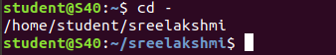

**13. cat > filename**

This command is used to create a file and add contents to that file.

Syntax :- $ cat > filename.txt

Output :-

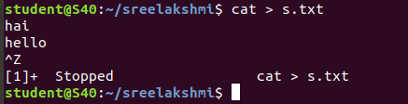

**14. cat filename**

This command is used to view the contents in the file.

Syntax :- $ cat filename.txt

Output :-

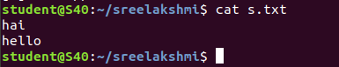

**15. cat>>filename**

This command is used to add contents to an existing file.

Syntax :- $ cat >> filename.txt

Output :-

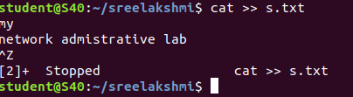

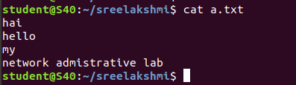

**16. cat filename1 > filename2**

This command is used to copy the content from one file to another file.

Syntax :- $ cat filename1 > filename2

Output :-





**Experiment No.: 6**

**Aim**

Familiarization of the linux commands.

**Procedure**

**1. read**

This command is used to read the content of a line to a variable.

Syntax :- $ read variablename

Output :-



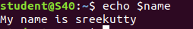

**4. find**

This command is used to display contents of particular directory.

Syntax :- $ find filename.txt

Output :-



**5. grep**

This command will let you search through all the text in a given file.

Syntax :- $ grep word filename.txt

Output:-

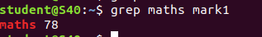

**grep -i**

command used for a case insensitive search

Syntax: $ grep -i filename.txt

Output:



**grep -v**

command used for inverted search.

Syntax: $ grep -v filename.txt

Output:

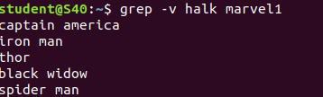

**grep -A1**

command used to display line after the result.

Syntax: $ grep -A1 filename.txt

Output:



**grep -B1**

command used to display line before the result.

Syntax: $ grep -B1 filename.txt

Output:



**grep -C1**

command used to display line before and after the result.

Syntax: $ grep -C1 filename.txt

Output:

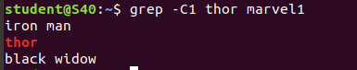

**9. wc -word count**

This command is used for counting purpose which is used to find the number of lines,the number of words,the number of characters and the number of bytes.

**wc -l** (count number of lines)

**wc -w** (count number of words)

**wc -c** (count number of characters)

**wc -m** (count number of bytes)

Syntax :- $ wc -l filename.txt

$ wc -w filename.txt

$ wc -c filename.txt

$ wc -m filename.txt

Output :-

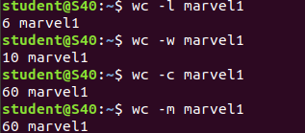

**6. df**

This command is used to get a report on system disc space usage.

Syntax :- $ df filename.txt

Output :-



**7. df -m**

This command is used to see the report in mega bytes.

Syntax :- $ def -m filename.txt

Output :-

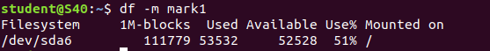

**9. wc -word count**

This command is used for counting purpose which is used to find the number of lines,the number of words,the number of characters and the number of bytes.

**wc -l** (count number of lines)

**wc -w** (count number of words)

**wc -c** (count number of characters)

**wc -m** (count number of bytes)

Syntax :- $ wc -l filename.txt

$ wc -w filename.txt

$ wc -c filename.txt

$ wc -m filename.txt

Output :-





**NETWORKING & SYSTEM ADMINISTRATION LAB**

**Experiment No.: 3**

**Aim**

Familiarization of the linux commands.

**Procedure**

**26.cut -d**

This command is used to cut and display the content based on the delimiter given.

Syntax :- $ cut –d delimiter –fieldnumber filename

Output :-

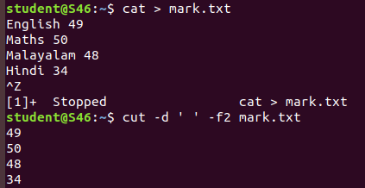

**27. cut -b**

This command is used tocut and display the content based on the specified byte number.

Syntax :- $ cut –b bytenumber filename

Output :-

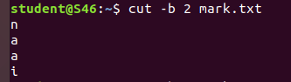

**28. cut --complement -c**

This command is used to erase the specified character and display the remaining content of the file.

Syntax :- $ cut --complement –c characternumber filename.txt

Output :-

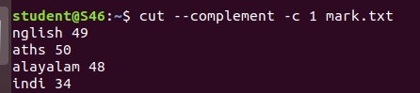

**29. paste**

This command is used to paste the contents from the specified file.

Syntax :- $ paste filename

Output :-

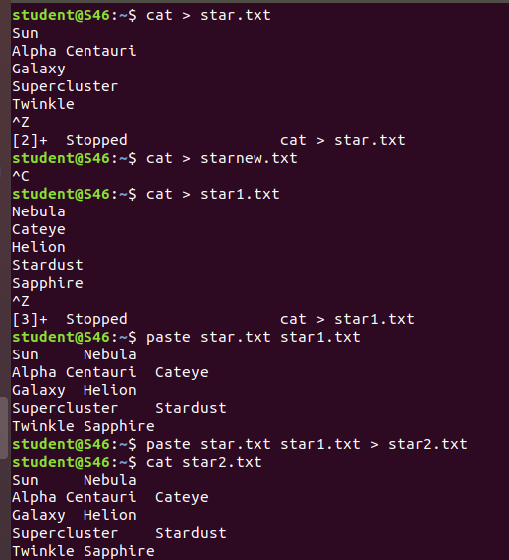

**30. paste file1 file2 > file3**

This command is used to paste the contents from the specified files to another file.

Syntax :- $ paste file1 file2 > file3

Output:-



**31. paste -s**

This command is used to paste the contents sequentially. It reads all the lines from the file and merges all these lines into a single linewith each line separated by tab.

Syntax :- paste –s file1 file2

Output :-

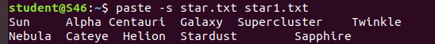

**32. paste -d**

This command is used to paste the contents from the given files with the delimiter given.

Syntax :- $ paste –d delimiter file1 file2

Output :-

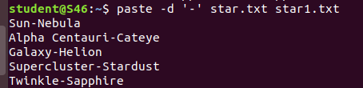

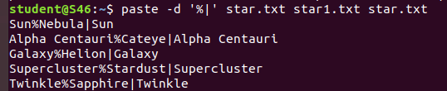

**33. more**

This command is used to view the text files in the command prompt, displaying one screen at a time in case the file is large.

Syntax :- $ more filename

Output :-

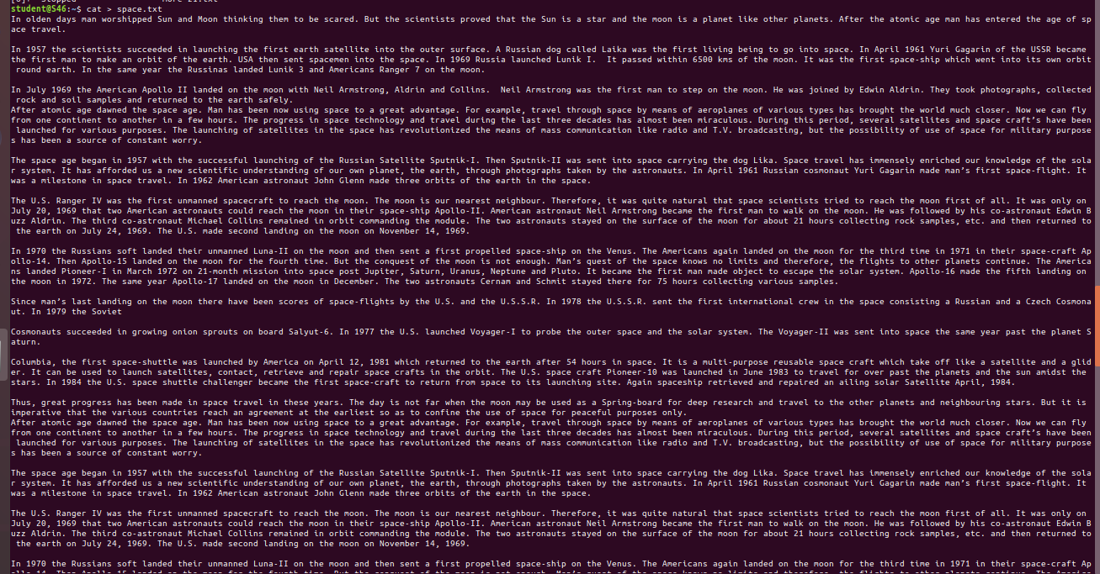

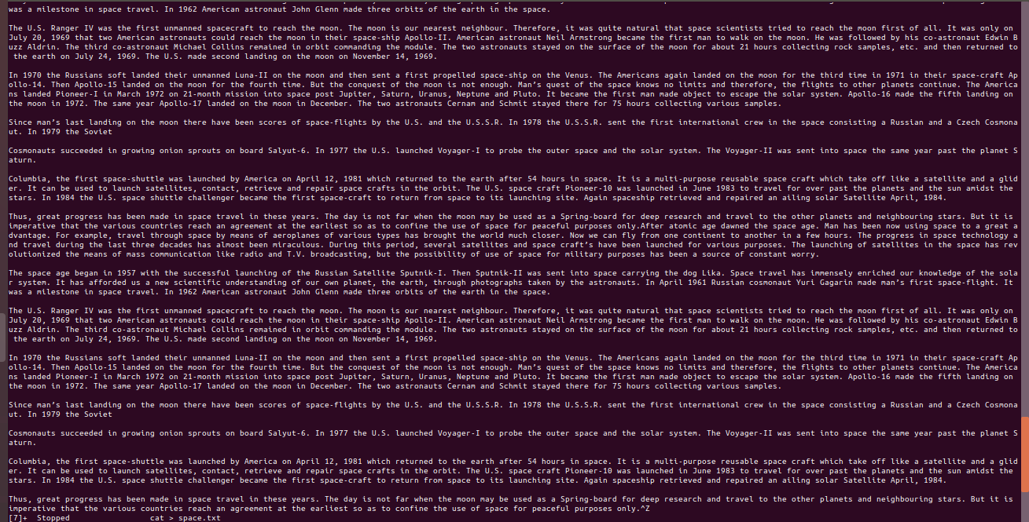

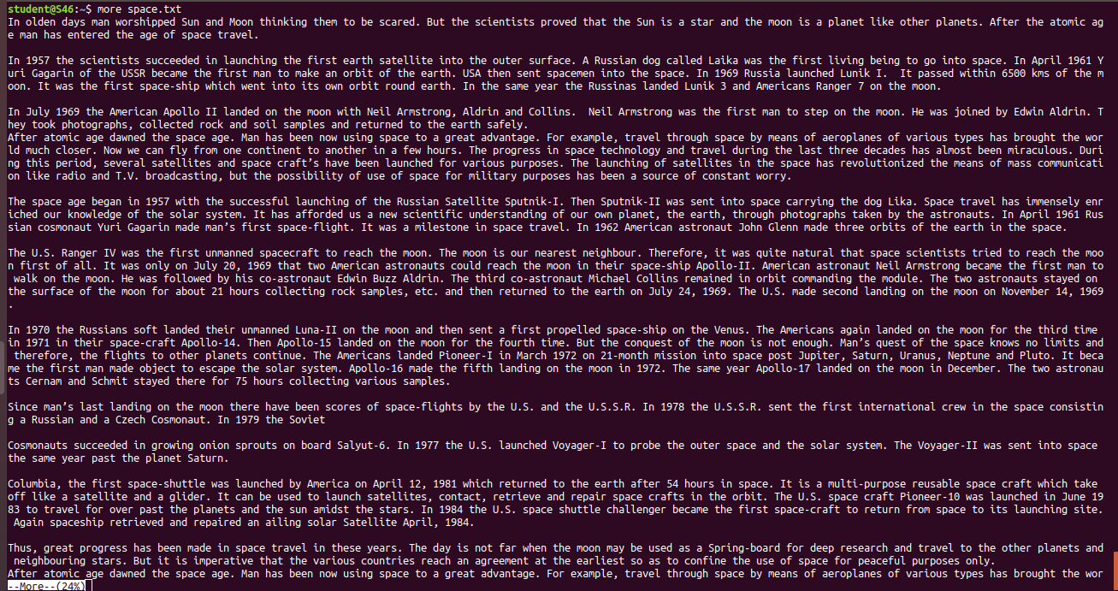

**34. more -number**

This command is used to display display the lines to the specified number from head.

Syntax :- $ more -number

Output :- 

**35. more +number**

This command use the line number from where we want to displaying the text content.

Syntax :- $ more +number

Output :-

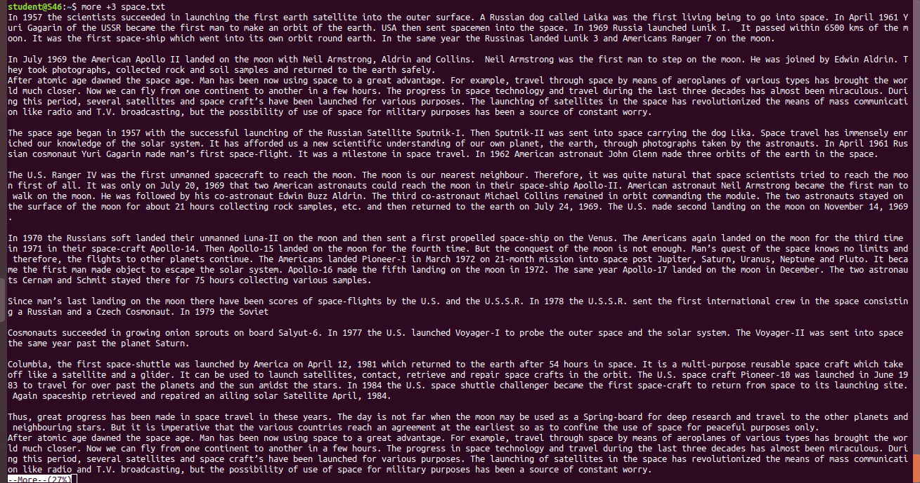



**NETWORKING & SYSTEM ADMINISTRATION LAB**

**Experiment No.: 3**

**Aim**

Familiarization of the linux commands.

**Procedure**

**36. cp**

This command is used to copy the contents from an existing file to a new file.

Syntax :- $ cpexisting_filenamenew_filename

Output :-

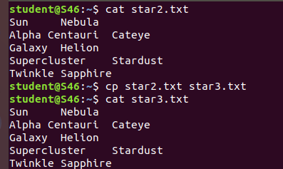

**37. cp -r**

This command is used to copy a directory along with its subdirectories.

Syntax :- $ cp -r source_directorydestination_directory

Output :-

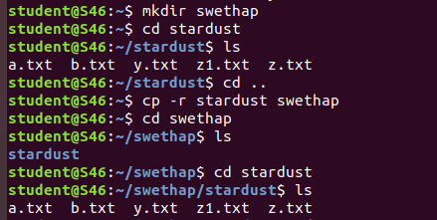

**38. cp overwriting**

This method is used to overwrite the contents of an existing file from one directory to an existing file with the same name in another directory with the cp command.

Syntax :- $ cp filename directoryname

Output :-

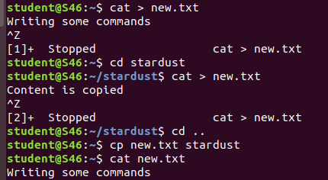

**39. cp-i**

This command is used to ask the confirmation message once before overwriting the file. We give ‘y’ or ‘n’ as the response.

Syntax :- $ cp -i filename destination_directory

Output :-

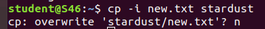

**40. mv**

This command is used to move an existing file or directory from one location to another.

Syntax :- $ mv filename directory_name

Output:-

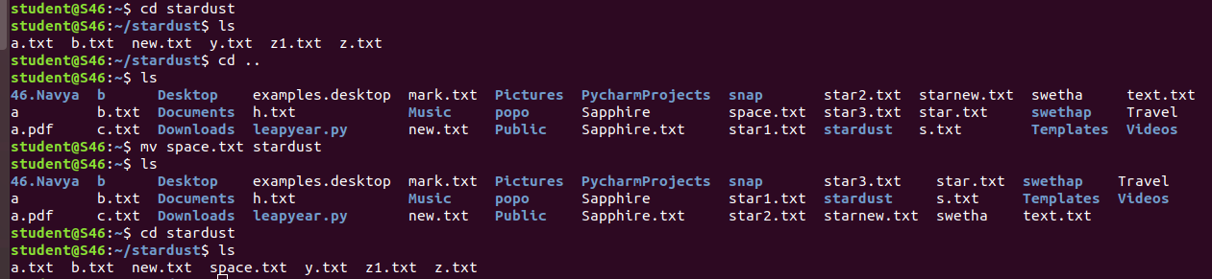

**41. mv overwriting**

This method is used to overwrite the contents of an existing file from one directory to an existing file with the same name in another directory with the mv command.

Syntax :- $ mv filename directory_name

Output :-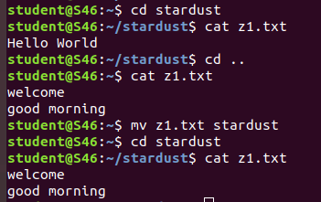

**21. head**

This command is used to display the first 10 lines of the file by default.

Syntax :- $ head filename

Output:-

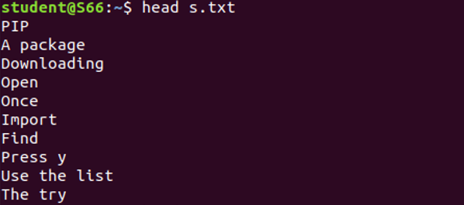

**22. head -number**

This command is used to display the lines of the file to the specified number from head.

Syntax :- $ head -number filename

Output :-

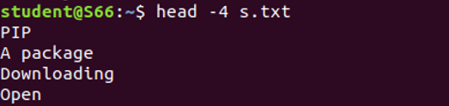

**23. tail**

This command is used to display the last 10 lines of the file by default. Syntax :- $ tail filename

Output :-

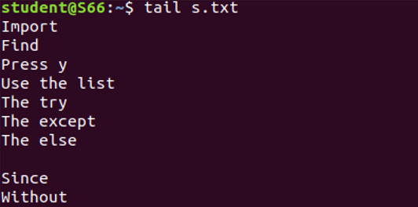

**24. tail -number**

This command is used to display the lines of the file to the specified number from tail.

Syntax :- $ tail -number filename

Output :-

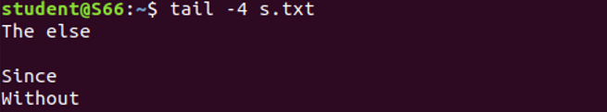



**NETWORKING & SYSTEM ADMINISTRATION LAB**

**Experiment No.: 7**

**Aim**

Familiarization of the linux commands.

**Procedure**

**1. sudo useradd**

This command is used to add new user.

Syntax :- $ sudo useradd username

Output :-



**2. sudo passwd**

This command is used to add password to the user.

Syntax :- $ sudo passwd username

Output :-

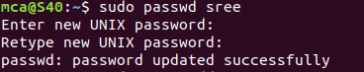

**4. sudo usermod**

This command is used to add members.

Syntax :- $sudo usermod -G groupname username

Output :-



**7. delete**

**sudo userdel username -** used to delete user.

**sudo groupdel groupname -** used to delete group name.

Syntax :- $  **sudo userdel username**

$ **sudo groupdel groupname**

Output :-





**9. chmod**

This command is used change directory permission of files.

**chmod +rwx**

**chmod -wx**

**chmod -rwx**

Syntax :- $ chmod +wx filename

$ chmod -wx filename

$ chmod -rwx filename

Output :-

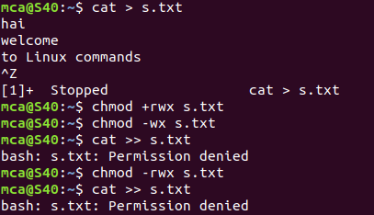

**10. chown**

This command is used to give ownership to user .

Syntax :-

$ sudo chown username filename

Output :-

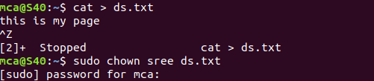

**11. ls -l**

This command is used to show the ownership details of particular file.

Syntax :-

$ ls -l filename.txt

Output :-



**12. ssh**

This command is used to provide a secure encrypted connection between two hosts over an insecure network.

Syntax :-

$ ssh mca@ipaddress

Output :-

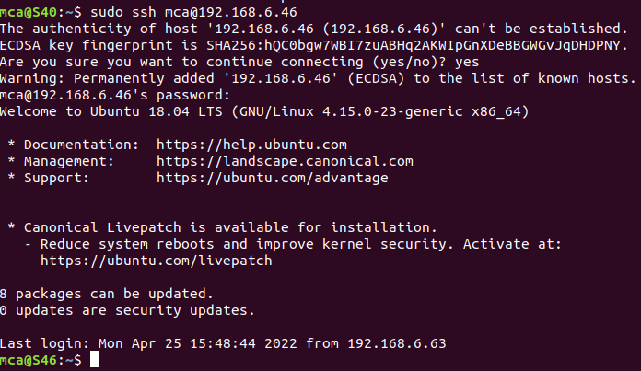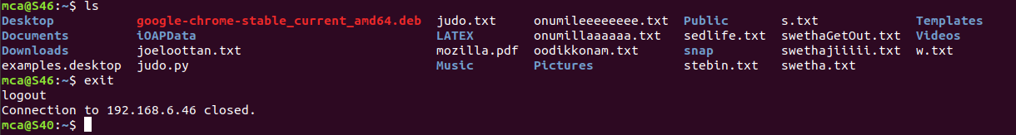

**NETWORKING & SYSTEM ADMINISTRATION LAB**



**Experiment No.: 28**

**Aim**

Build and install software from source code, familiarity with make and cmake utilities expected.

**Procedure**

**Step 1** : Create a Shell Script

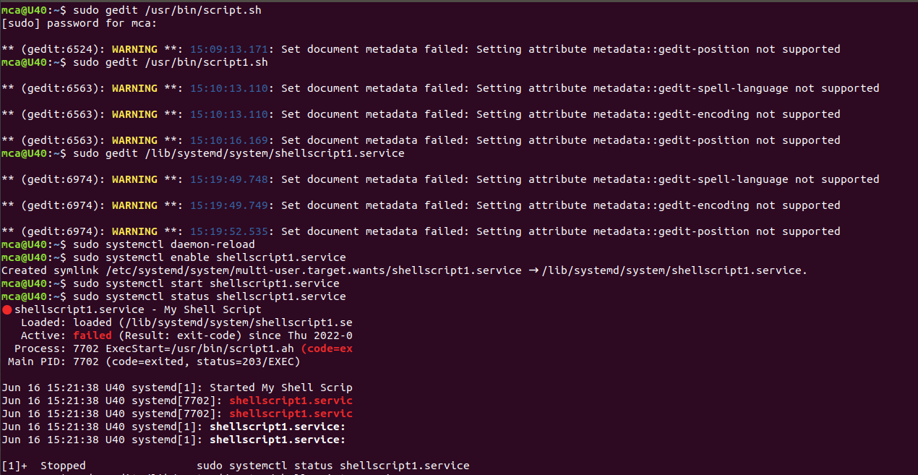

Add the following sample script.

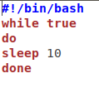

Save script and set execute permission.

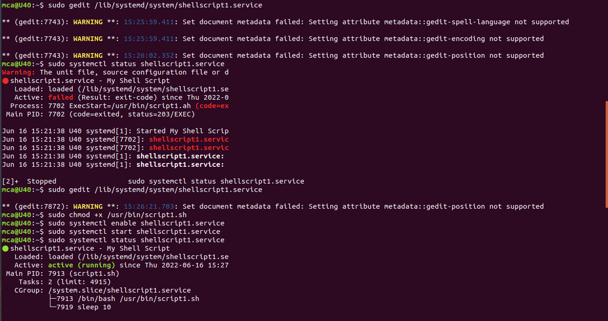

## Step 2: Create A SystemD File, and  add the following content and update the script filename and location. You can also change the description of the service.

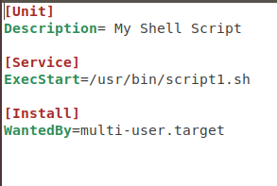

## Step 4: Enable New Service



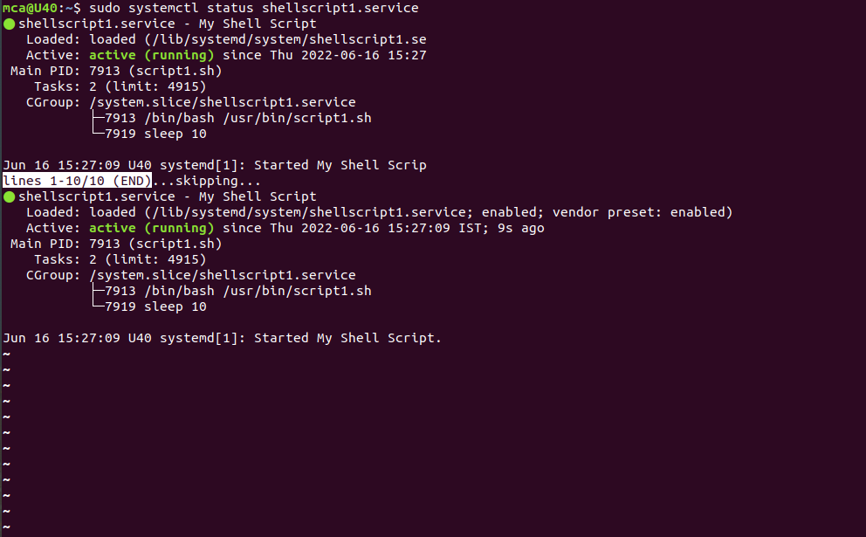



**NETWORKING & SYSTEM ADMINISTRATION LAB**

**Experiment No.: 8**

**Aim**

write shell script to print details

**Program**

#!/bin/bash

echo "enter your name"

read name

read $name

echo "course of studing"

read course

echo $course

echo "year of studing"

read yr

echo $yr

echo "entered details is:"

echo $name $course $yr

**Output:**

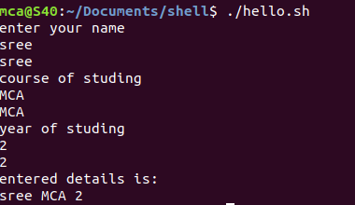

**Aim**

write shell script to find largest of two numbers

**Program**

#!/bin/bash

echo "Enter the first number"

read a

echo "enter the second number"

read b

if [ $a -gt $b ]

then

echo $a" is largest"

else

echo $b "is largest"

fi

**Output:**

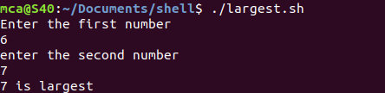

**Aim**

write shell script to find largest of three numnbers

**Program**

#!/bin/bash

echo "Enter the first number"

read a

echo "enter the second number"

read b

echo "enter the second number"

read c

if [ $a -gt $b ] && [ $a -gt $c]

then

echo $a" is largest"

elif [ $b -gt $c ] && [ $b -gt $c]

then

echo $b "is largest"

else

echo $c "is largest"

fi

**Output:**

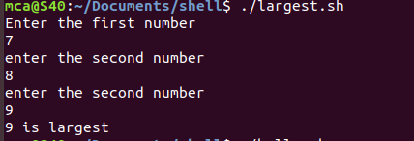

**Aim**

write shell script to print sum of two numbers

**Program**

#!/bin/bash

echo "Enter the first number"

read num1

echo "enter the second number"

read num2

sum=$(($num1+$num2))

echo "the sum is:"$sum

**Output:**

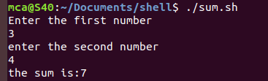

**Aim**

write shell script to print number is even or odd

**Program**

#!/bin/bash

echo "Enter the first number"

read a

r=$(($ % 2))

if [ $r == 0 ]

then

echo "number is even"

else

echo "number is odd"

fi

**Output:**





**NETWORKING & SYSTEM ADMINISTRATION LAB**

**Experiment No.: 9**

**Aim**

write shell script to display current date and calender

**Program**

#!/bin/bash

echo "current date:"$(date)

echo "current year calender:"

cal

**Output:**

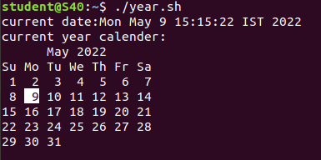

**Experiment No.: 10**

**Aim**

write shell script to find number is greater ,less than or equal to another number.

**Program**

#!/bin/bash

echo "Enter first number : "

read num1

echo "Enter second number : "

read num2

if [ $num1 -gt $num2 ]

then

echo "First Number is Greatest!!"

elif [ $num1 -lt $num2 ]

then

echo "Second Number is greatest!!"

elif [ $num1 -eq $num2 ]

then

echo "First and Second Number is Equal.."

fi

**Output:**

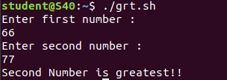

**Experiment No.: 11**

**Aim**

write shell script to find sum of first 10 numbers.

**Program**

#!/bin/bash

echo "Enter Size(N)"

read N

i=1

sum=0

echo "Enter Numbers"

while [ $i -le $N ]

do

read num #get number

sum=$((sum + num)) #sum+=num

i=$((i + 1))

done

echo $sum

fi

**Output:**

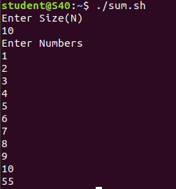

**Experiment No.: 12**

**Aim**

write shell script to find the sum ,the average and the product of the four numbers.

**Program**

#!/bin/bash

echo "enter four integers"

read a b c d

sum=$(echo "$a + $b + $c + $d" | bc -l)

average=$(echo "$sum / 4" | bc -l)

product=$(echo "$a * $b * $c * $d" | bc -l)

echo "sum = $sum"

echo "Average = $average"

echo "Product = $product"

**Output:**

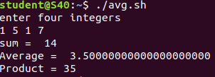

**Experiment No.: 13**

**Aim**

write shell script to find factorial of a given number

**Program**

#!/bin/bash

echo "Enter a number"

read num

fact=1

while [ $num -gt 1 ]

do

fact=$((fact * num)) #fact = fact * num

num=$((num - 1)) #num = num - 1

done

echo $fact

**Output:**

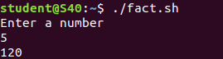

**Experiment No.: 14**

**Aim**

write shell script to check whether the number is palidrome or not .

**Program**

#!/bin/bash

echo "Enter the number"

read n

number=$n

reverse=0

while [ $n -gt 0 ]

do

a=`expr $n % 10 `

n=`expr $n / 10 `

reverse=`expr $reverse \* 10 + $a`

done

echo $reverse

if [ $number -eq $reverse ]

then

echo "Number is palindrome"

else

echo "Number is not palindrome"

fi

**Output:**

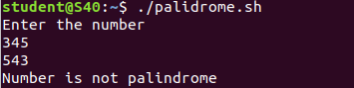

**Experiment No.: 15**

**Aim**

write shell script to check whether the given year is leap year or not .

**Program**

echo "enter the year :"

read y

a=`expr $y % 4`

b=`expr $y % 100`

c=`expr $y % 400`

# -eq is for equal to

#-ne is for not equal to

if [ $a -eq 0 -a $b -ne 0 -o $c -eq 0 ]

then

echo "$y is leap year"

else

echo "$y is not leap year"

fi

**Output:**

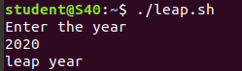



**NETWORKING & SYSTEM ADMINISTRATION LAB**

**Experiment No.: 16**

**Aim**

write shell script to find sum of all digits in a number.

**Program**

#!/bin/bash

echo "Enter a number"

read num

s=0

while [ $num -gt 0 ]

do

mod=$((num % 10))

s=$((s +mod))

num=$((num / 10))

done

echo $s

**Output:**

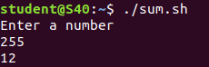

**Experiment No.: 17**

**Aim**

write shell script to find the average of number of numbers entered in a given line.

**Program**

#!/bin/bash

echo "Enter size"

read size

i=1

s=0

echo "Enter Numbers"

while [ $i -le $size ]

do

read num

s=$((s+num))

i=$((i+1))

done

avg=$(echo $s / $size | bc -l)

echo $avg

**Output:**

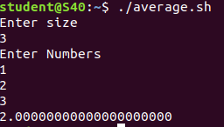

**Experiment No.: 18**

**Aim**

write shell script to find addition using switch case.

**Program**

#!/bin/bash

echo "Enter two numbers"

read a

read b

echo "Enter choice :"

echo "1. addition"

echo "2.Substraction"

echo "3.Multipilcation"

echo "4.Division"

read ch

case $ch in

1)res=`echo $a + $b | bc`

;;

2)res=`echo $a - $b | bc`

;;

3)res=`echo $a \* $b | bc`

;;

4)res=`echo "scale=2; $a / $b" | bc`

;;

esac

echo "Result : $res"

**Output:**

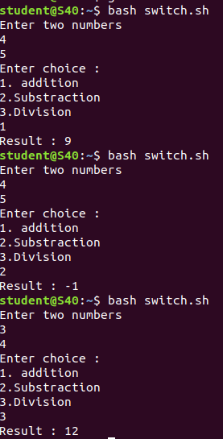

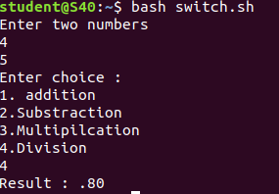

`

**NETWORKING & SYSTEM ADMINISTRATION LAB**

**Experiment No.: 24**

**Aim**

Install Linux, Apache, MySQL, PHP (LAMP) stack on Ubuntu 18.04

**Procedure**

**INSTALLING APACHE**

**Step 1** : Installing Apache and Updating the Firewall

The Apache web server is a popular open source web server that can be used along with PHP to host dynamic websites.

First, make sure your apt cache is updated with:

Syntax: $ sudo apt update

**Output:**

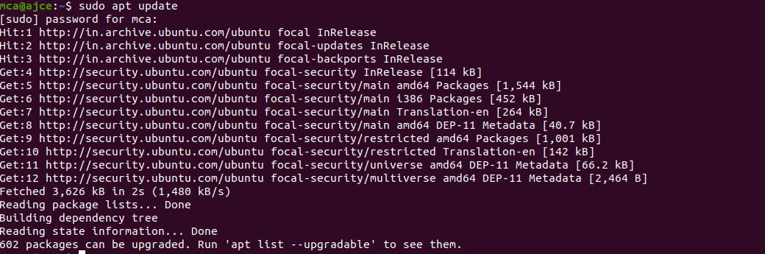

**Step 2** : Install Apache 2

Once the cache has been updated, you can install Apache with:

Syntax: $ sudo apt update

Press Y and hit ENTER to confirm, and the installation will proceed.

**Output:**

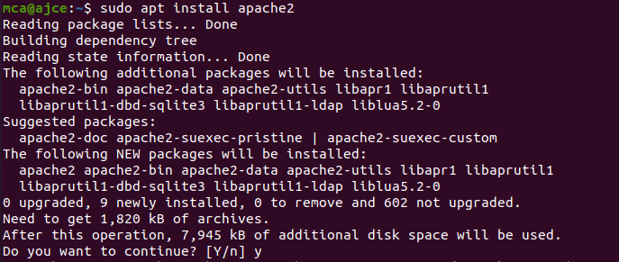

**Step 3** : Adjust the Firewall to Allow Web Traffic

Next, assuming that you have followed the initial server setup instructions and enabled the UFW firewall, make sure that your firewall allows HTTP and HTTPS traffic. You can check that UFW has an application profile for Apache.

**Output:**

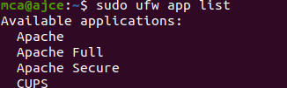

**Step 4** : Check Apache Full

Apache Full profile details, you’ll see that it enables traffic to ports 80 and 443:

Syntax: sudo ufw app info "Apache Full"

**Output:**

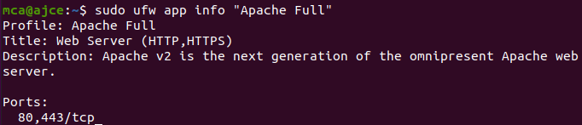

To allow incoming HTTP and HTTPS traffic for this server, run

Syntax: sudo ufw allow "Apache Full"

**Output:**

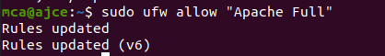

**Step 5** : A spot check right away to verify that everything went as planned by visiting your server’s public IP address in your web browser

**Output:**

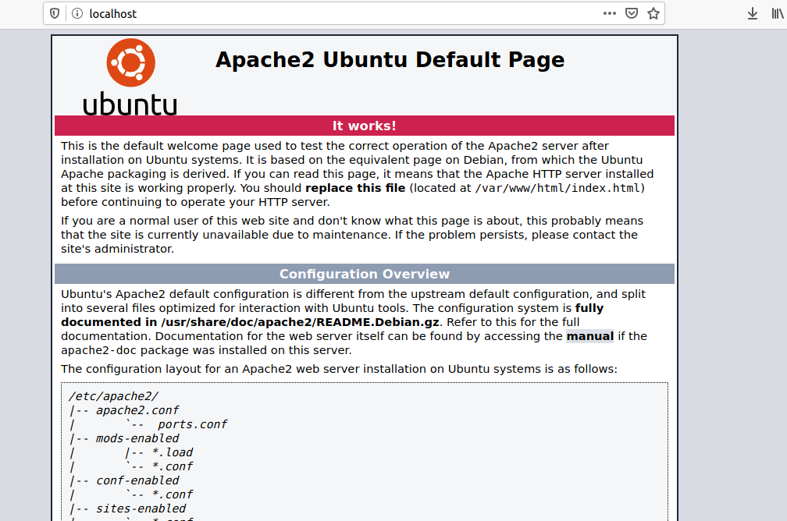

**Installing MySQL**

**Step 1** : In this case, you do not have to run sudo apt update prior to the command. This is because you recently ran it in the commands above to install Apache. The package index on your computer should already be up-to-date.

Syntax: $ sudo apt install mysql-server

**Output:**

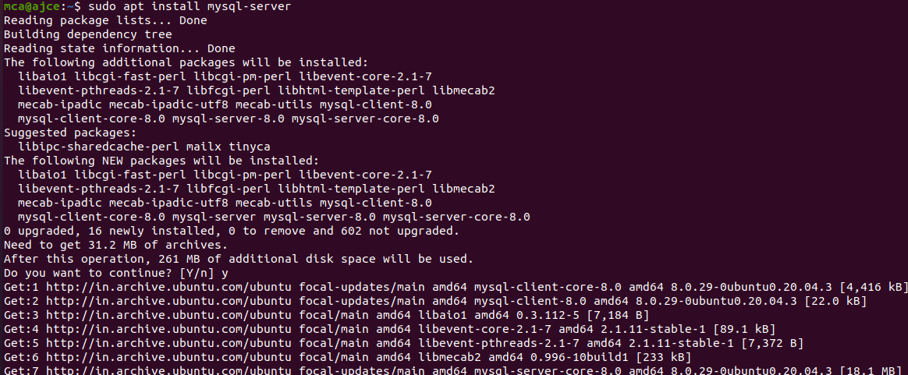

**Step 2** :

This will connect to the MySQL server as the administrative database user root, which is inferred by the use of sudo when running this command.

Syntax: $ sudo mysql

**Output:**

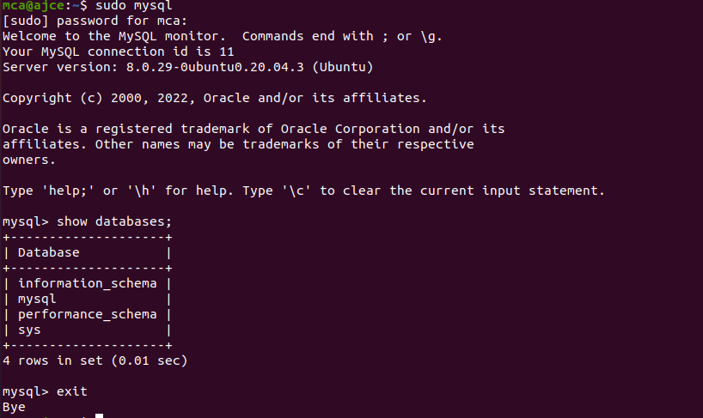

**Installing PHP**

In addition to the php package, you’ll also need libapache2-mod-php to integrate PHP into Apache, and the php-mysql package to allow PHP to connect to MySQL databases. Run the following command to install all three packages and their dependencies.

**Step 1** : Installation

Syntax: sudo apt install php libapache2-mod-php php-mysql

**Output:**

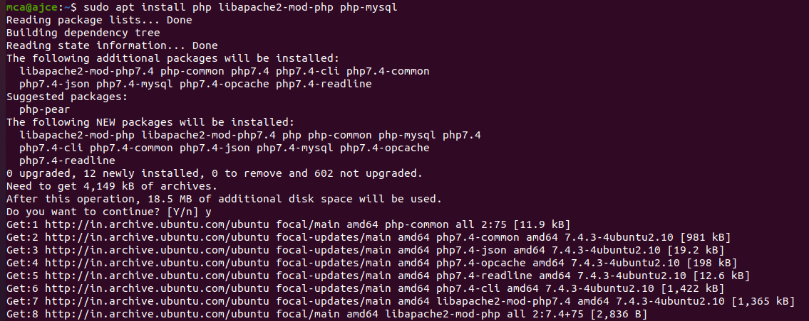

**Step 2** : Restart

Syntax: sudo systemctl restart apache2

**Output:**



**Step 3** : Testing PHP Processing on your Web Server

**Output:**



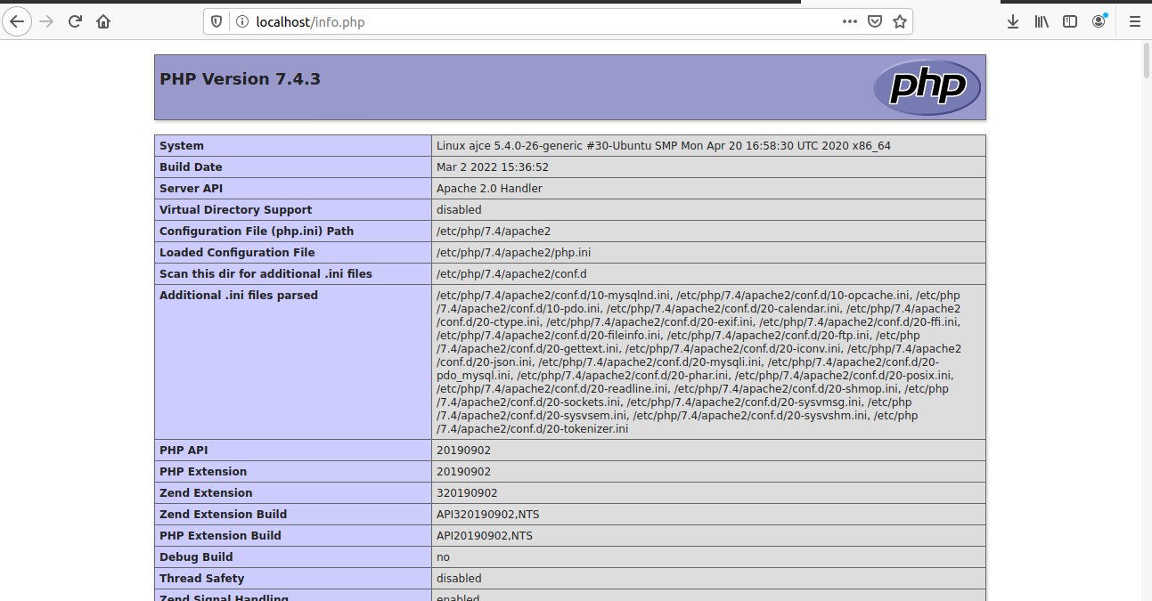

**Install WordPress with LAMP on Ubuntu 18.04**

**Step 1** : Download WordPress

Syntax: $ wget -c http://wordpress.org/latest.tar.gz

$ tar -xzvf latest.tar.gz

**Output:**

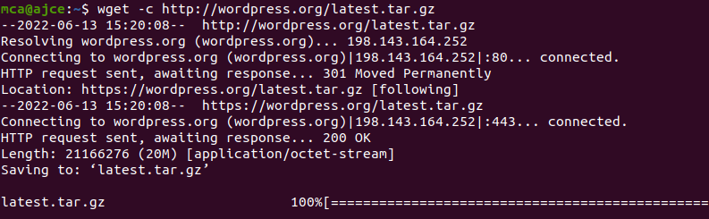

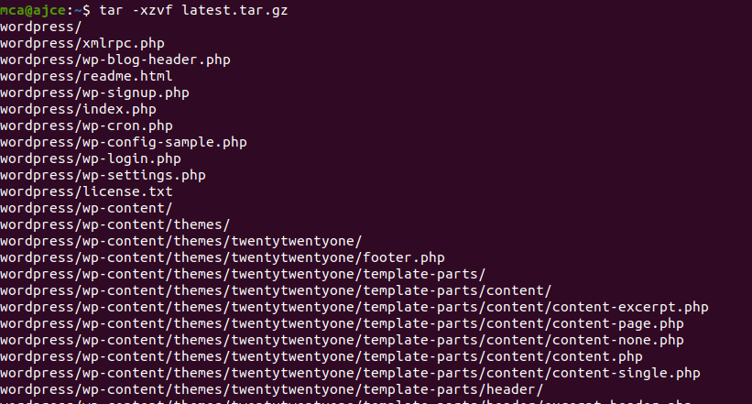

**Step 2** : Creating a MySQL Database and User for WordPress

The first step you’ll take is a preparatory one. Even though MySQL is already installed, you still need to create a database to manage and store the user information for WordPress to use. To get started, log into the MySQL root (administrative) account by issuing the following command:

Syntax: $ sudo mysql

You will be prompted for the password you set for the MySQL root account when you installed the software. However, if you have password authentication enabled for your root user, you can run the following command and enter your password information when prompted:

Syntax: $ mysql -u root –p

**Output:**

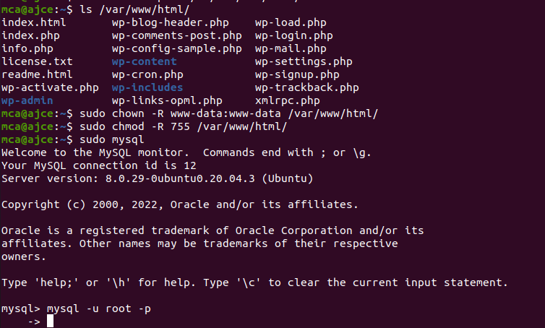

**Step 3** : Create the database for WordPress

**Output:**

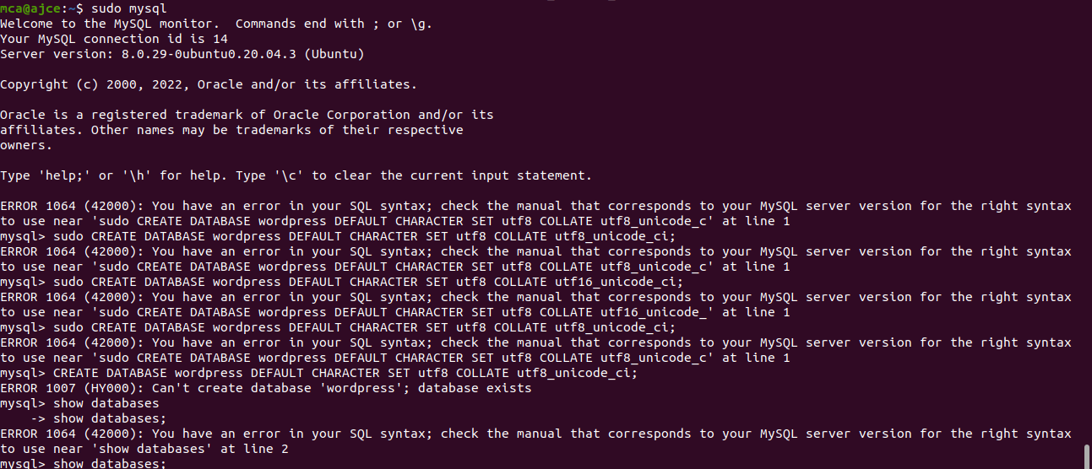

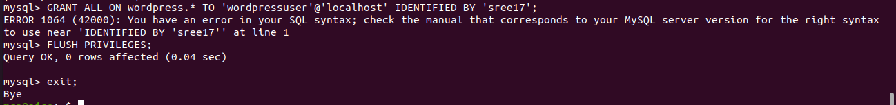

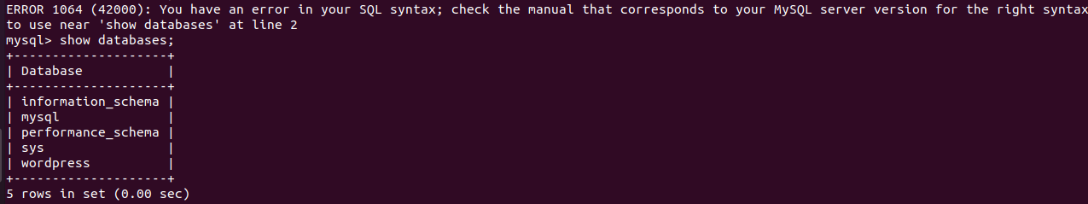

**Step 2** :

Go the /var/www/html/ directory and rename existing wp-config-sample.php to wpconfig.php. Also, make sure to remove the default Apache index page.

Syntax: sudo mv wp-config-sample.php wp-config.php

sudo rm -rf index.html

**Output:**

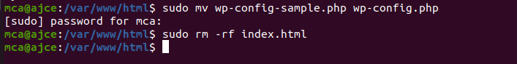

**Step 3** :

Then update it with your database information under the MySQL settings section (refer to the highlighted boxes in the image below): This setting can be added after the database connection settings, or anywhere else in the file:.

Syntax:

define('DB_NAME', 'wordpress');

/** MySQL database username */

define('DB_USER', 'wordpressuser');

/** MySQL database password */

define('DB_PASSWORD', 'password');

. . .

define('FS_METHOD', 'direct');

**Output:**

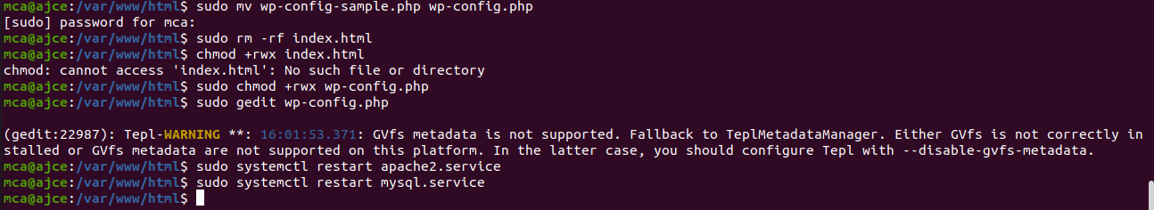

Save and close the file when you are finished.

**Step 4**: Restart the web server and mysql service

Syntax: $sudo systemctl restart apache2.service

$ sudo systemctl restart mysql.service

**Output:**



**Step 5**: Completing the Installation Through the Web Interface

The server configuration is complete, you can complete the installation through the web interface.In your web browser, navigate to your server’s domain name or public IP address

**Output:**

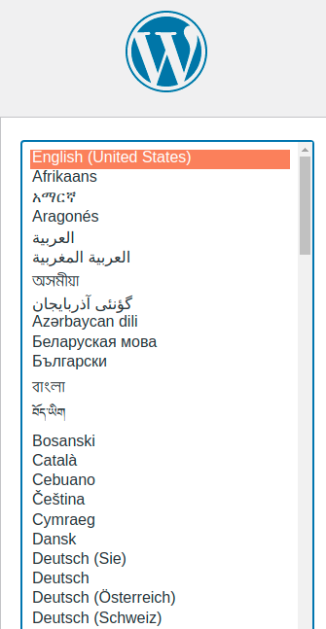

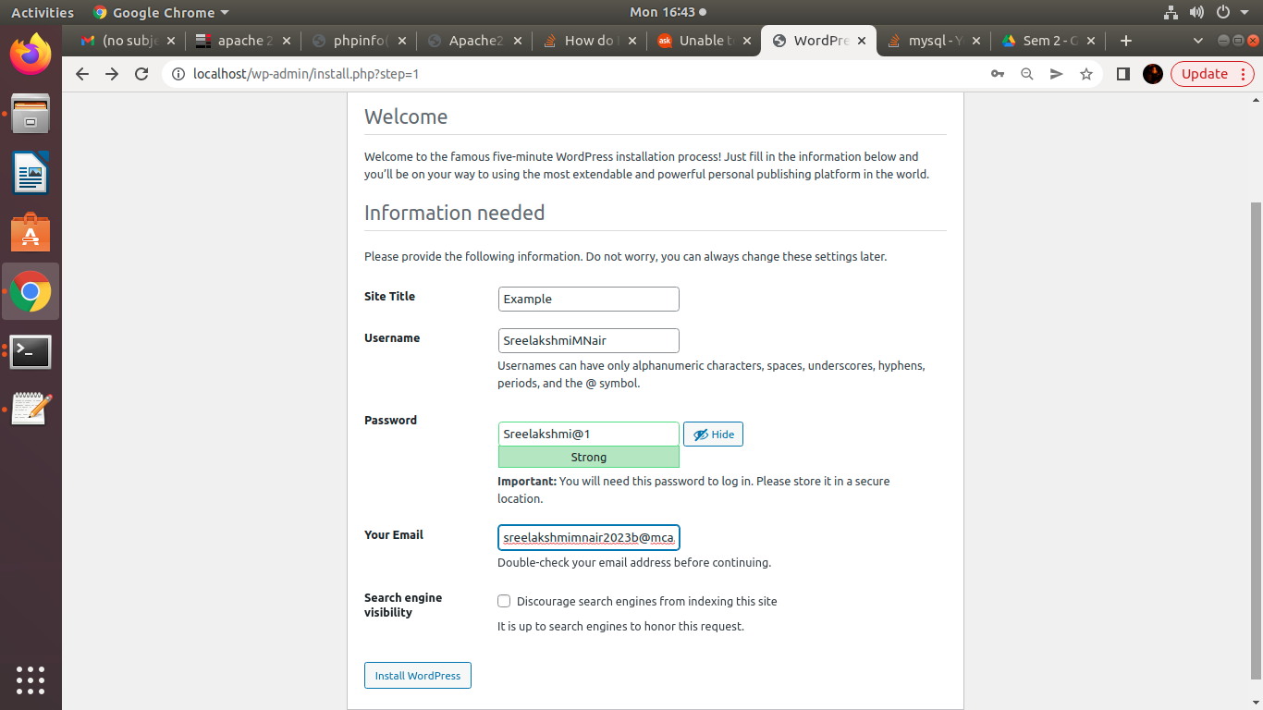

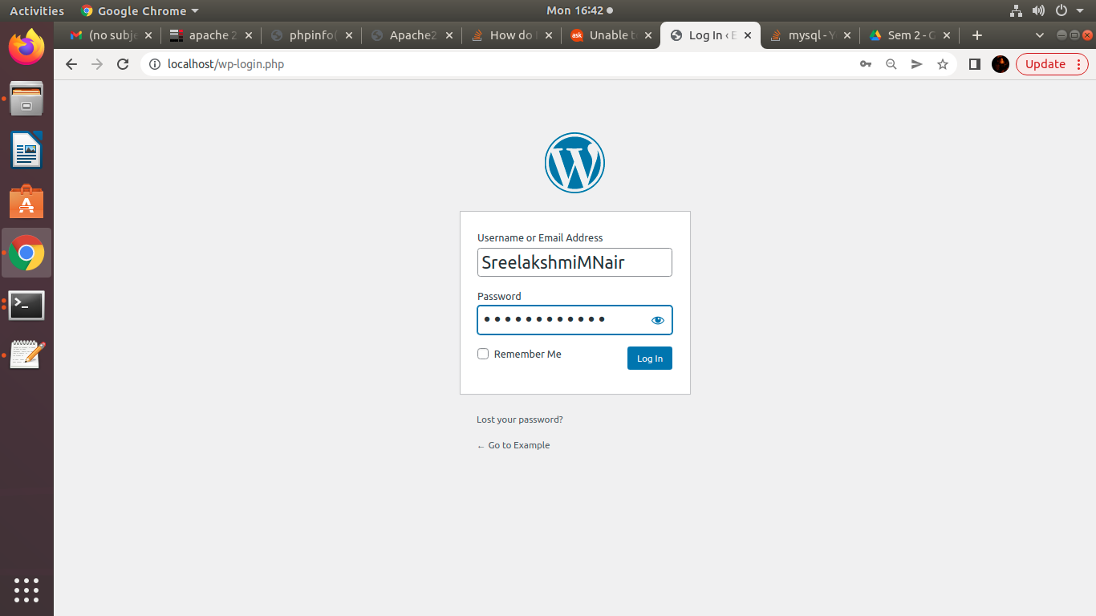



**NETWORKING & SYSTEM ADMINISTRATION LAB**



**Experiment No.: 28**

**Aim**

Build and install software from source code, familiarity with make and cmake utilities expected.

**Procedure**

**Step 1** : Create a Shell Script



Add the following sample script.



Save script and set execute permission.



## Step 2: Create A SystemD File, and  add the following content and update the script filename and location. You can also change the description of the service.



## Step 4: Enable New Service







**NETWORKING & SYSTEM ADMINISTRATION LAB**

**Experiment No.: 25**

**Aim**

Familiarization of basic network commands in windows

**Procedure**

**1. ipconfig**

This commands in windows allows you to see a summarized information of your network such as ip address, subnet mask , server address etc.

**Syntax :-** $ ipconfig

**Output :-**

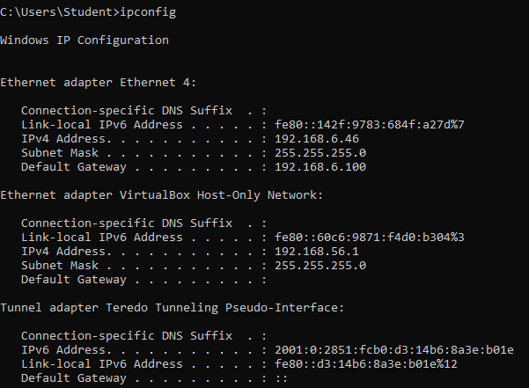

**2. ipconfig/all**

To see the the network information in detail. It is an extension of ipconfig command

**Syntax :-** $ ipconfig/all

**Output** :-

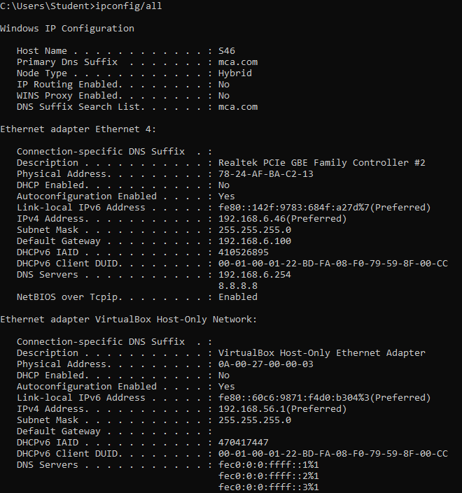

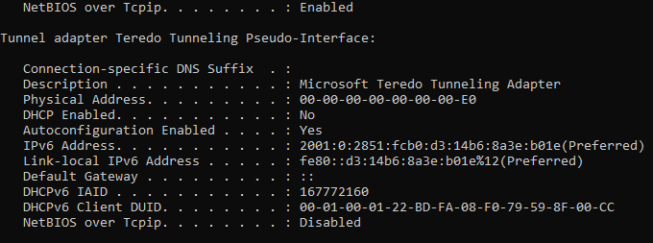

**3.** **nslookup**

To show the server to which the system is connected by default. If we want to find the ip address of a particular domain name, we can also use nslookup

**Syntax :-** $ nslookup

**Output :-**

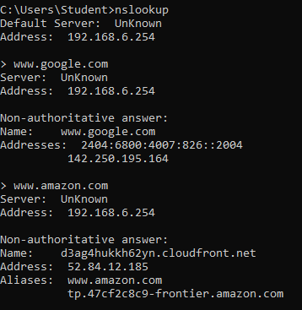

**4. ping**

The command used to check the availability of a host. The response shows the URL you are pinging, the ip address associated with the URL and the size of packets being sent on the first line . The next four lines shows the replies from each individual packets including the time(in milliseconds) for the response and the time to live(TLL) of the packet, that is the amount of time that must pass before the packet discarded.

**Syntax :-**  $ ping <IP_address>

**Output :-**

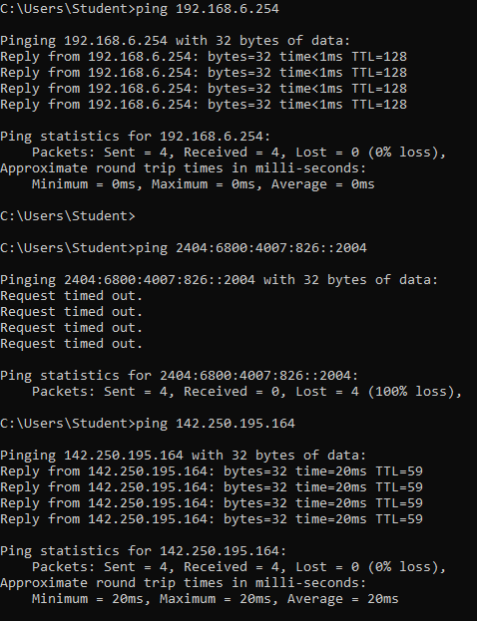

**5. tracert**

The command used to show the packets that are passed through the router to which our system is connected to.

**Syntax :-** $ tracert <ip_address_of_system>

**Output :-**

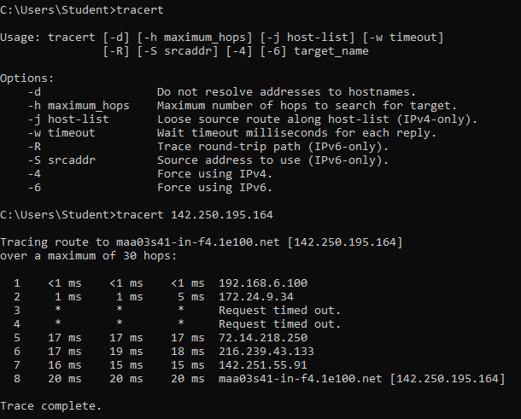

**6. route print**

The command used to display and updates network routing table

**Syntax :-** $ route print

**Output :-**

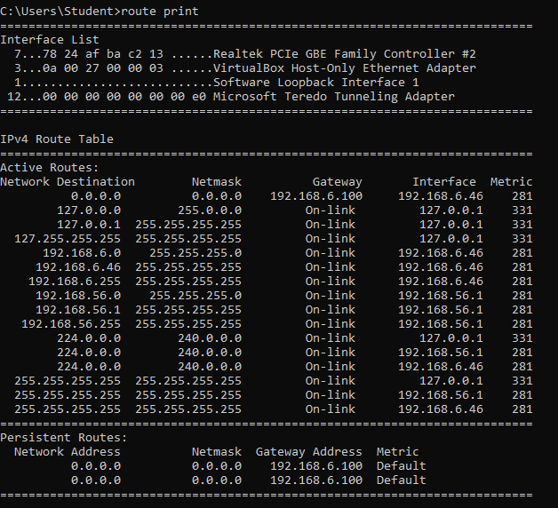

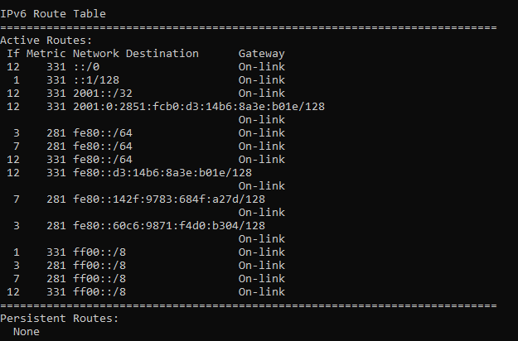

**7. netstat**

The network statistics or netstat command is a networking tool used for troubleshooting and configuration that can also serve a monitoring tool for the connections over the network.

**Syntax :-** netstat

**Output :-**

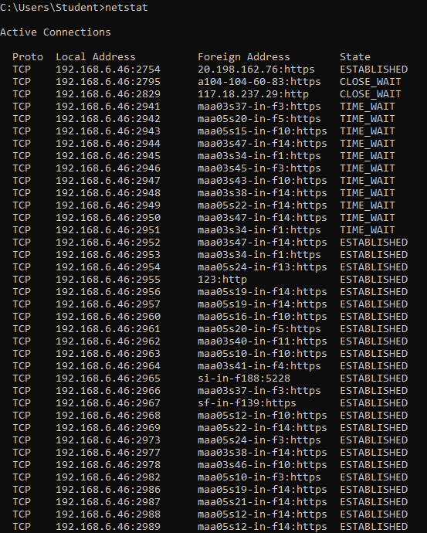



**NETWORKING & SYSTEM ADMINISTRATION LAB**

**Experiment No.: 23**

**Aim**

TCPDUMP installation.

**Procedure**

**1. update and install**

This command is used to install and update tcpdump.

Syntax :- $ sudo apt update && sudo apt install tcpdump

Output :-

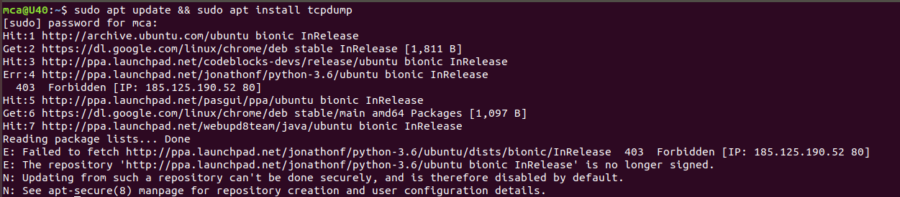

**2. sudo tcpdump**

This command is used to show all the interfaces connected to the inertnet packets.

Syntax :- $ sudo tcpdump

Output :-

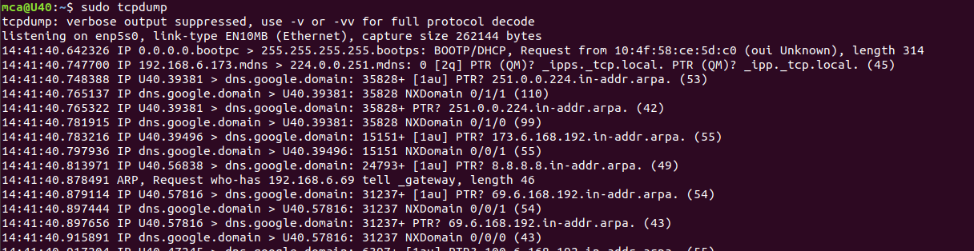

**3. -D**

This command is used to find specific interfaces.

Syntax :- $ sudo tcpdump -D

Output :-

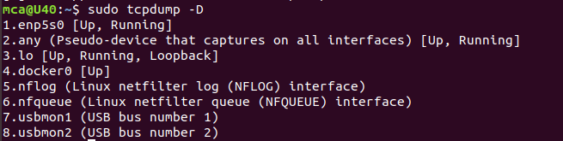

**4. -i**

This command is used to find the interface which is connected to our system.

Syntax :- $ sudo tcpdump -i enp5s0

Output :-

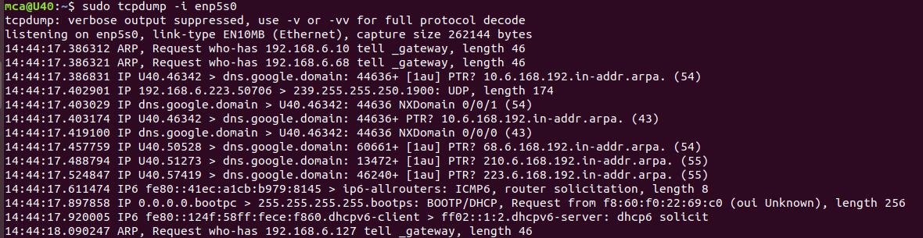

**5. -c 5 -i**

This command is used to access only 5 packets.

Syntax :- $ sudo tcpdump -c 5 -i enp5s0

Output:-

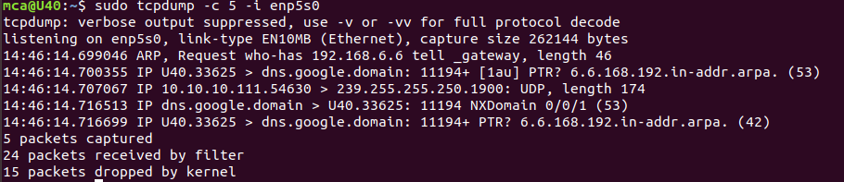

**6. -xx -i**

This command is used show all nformation in ASCII value.

Syntax :- $ sudo tcpdump -xx -i enp5s0

Output :-

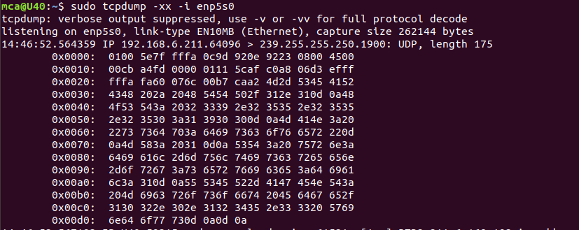

**7. sudo tcpdump -i enp5s0 -c 5 port 80**

This command is used to show a specified number of packets in that particular port number.

Syntax :- $ sudo tcpdump -i enp5s0 -c 5 port 80

Output :-

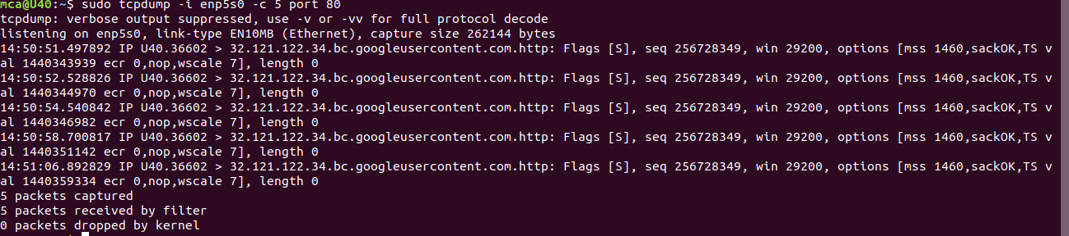

**8. sudo tcpdump -i enp5s0 icmp**

Syntax :- $ sudo tcpdump -i enp5s0 icmp

Output :-

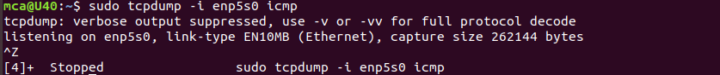

**9. sudo tcpdump -i enp5s0 -c 10 -w icmp.filename**

This command is used to capturing packets and stored in a pcap file.

Syntax :- $ sudo tcpdump -i enp5s0 -c 10 -w icmp.filename

Output :-

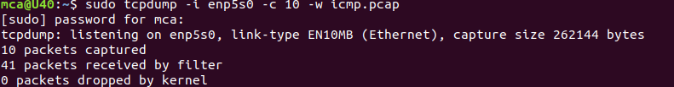

**10. sudo tcpdump -r icmp.filename**

This command use to read that particular file using -r flag.

Syntax :- $ sudo tcpdump -r icmp.filename

Output :-

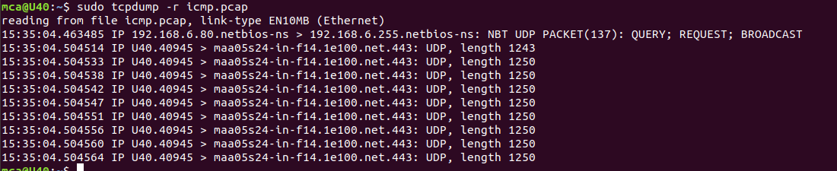

**NETWORKING & SYSTEM ADMINISTRATION LAB**

**Experiment No.: 23**

**Aim**

Install and use the latest version of Wireshark on Ubuntu.

**Procedure**

**Step 1** : First update APT package repository.

Syntax: $ sudo apt update

**Output:**

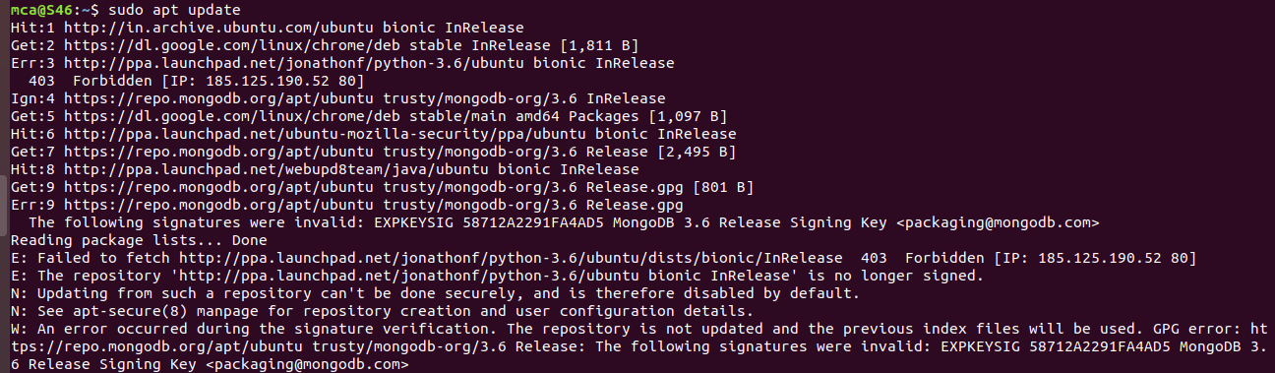

**Step 2** : Install wireshark

Syntax: $ sudo apt install wireshark

Now press **y** and then press **Enter.**

**Output:**

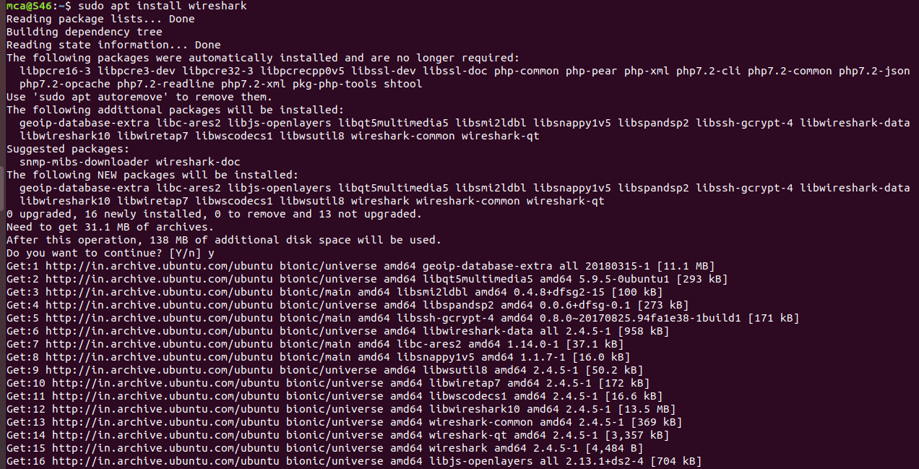

**Step 3** : By default, Wireshark must be started as root privileges in order to work. If you want to run Wireshark without root privileges or without sudo, then select **Yes** and press **Enter**.

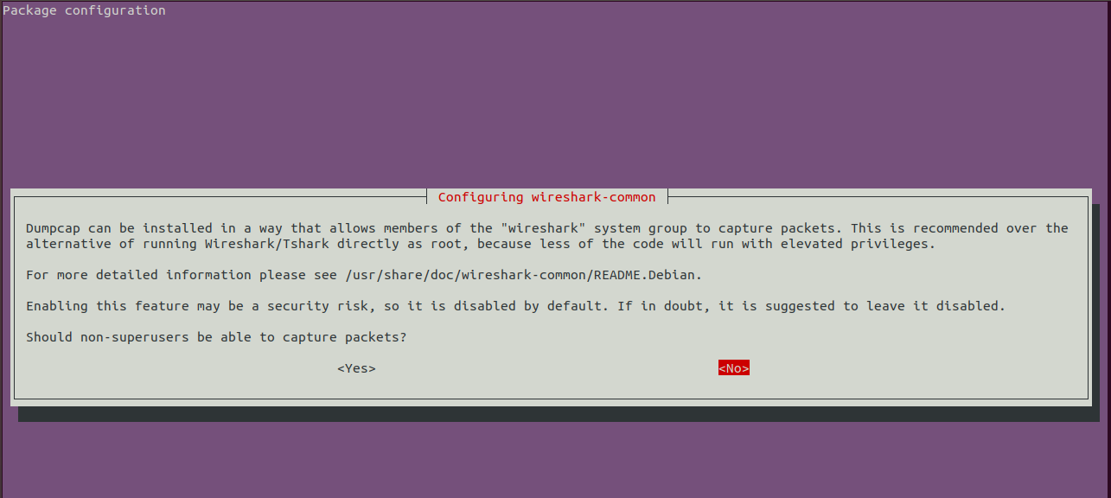

Wireshark should be installed.

**Step 4** : To add user to the wireshark group:

Syntax: sudo adduser $mca wireshark

**Output:**



**Step 5** : Now that Wireshark is installed, you can start Wireshark from the Application Menu of Ubuntu.

If you did not enable Wireshark to run without **root** privileges or **sudo**, then the command should be:

Syntax: sudo wireshark



Wireshark should start.

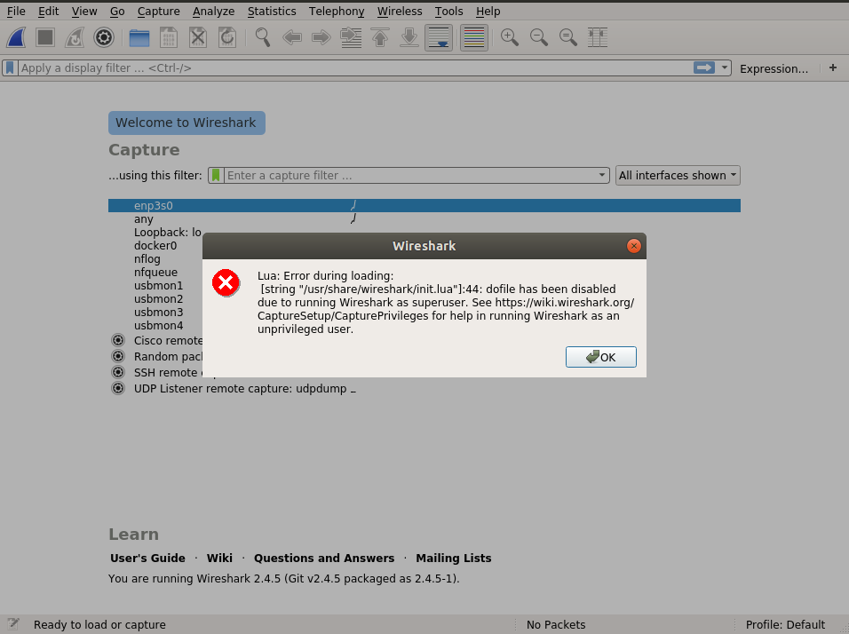

When we start Wireshark, you will see a list of interfaces that you can capture packets to and from.

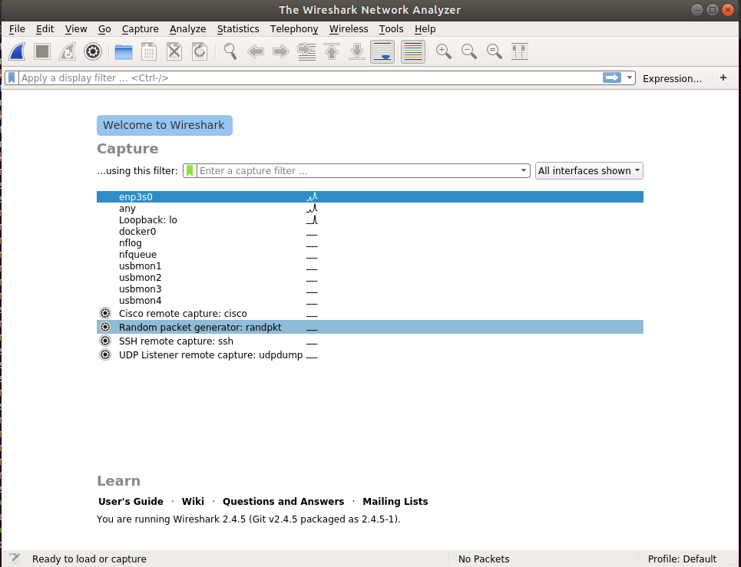

Now to start capturing packets, just select the interface and click on the start capturing packets icon above.

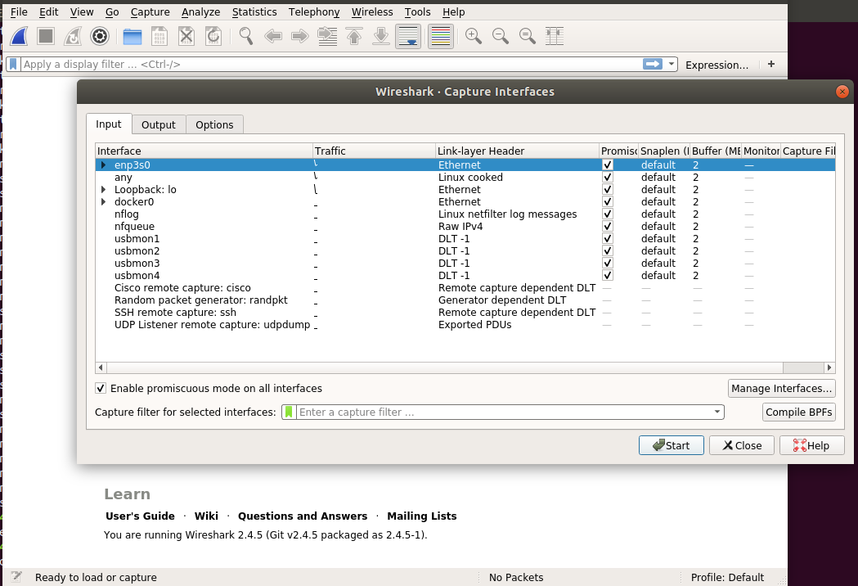

We can capture packets on any network interface.

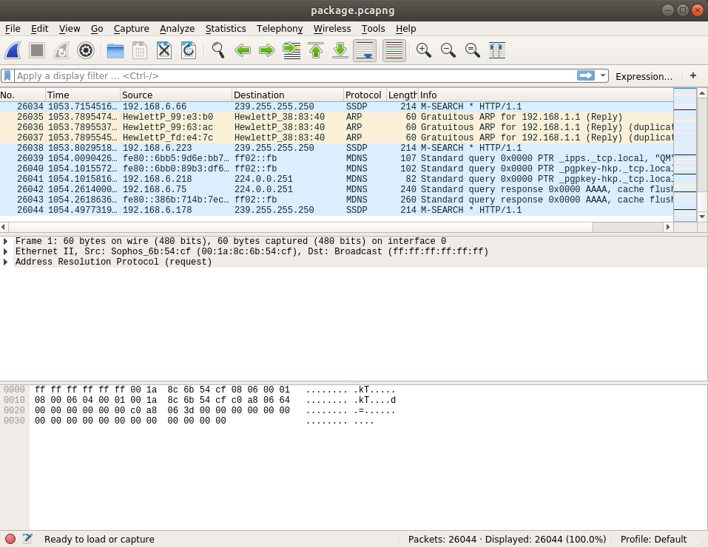

**NETWORKING & SYSTEM ADMINISTRATION LAB**



**Experiment No.: 19**

**Aim**

KVM Installation.

**Procedure**

**Step 1:** Update the repositories

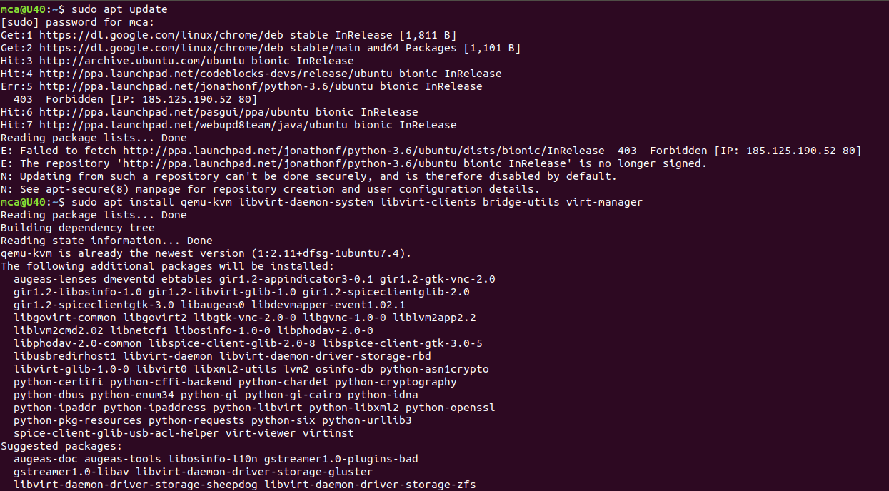

**Step 2:** Install essential KVM packages

 Install virt-manager, a tool for creating and managing VMs



**Step 3:** Start virt-manager with

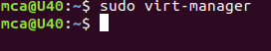

**Step 4**: In the first window, click the computer icon in the upper-left corner,

In the dialogue box that opens, select the option to install the VM using an ISO image. Then click Forward.

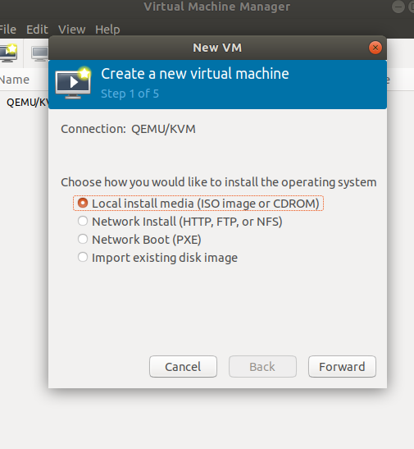

**Step 5:** Choose ISO,click Forward

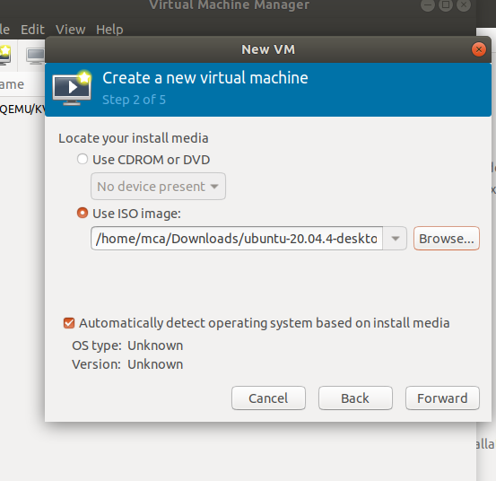

**Step 6:** Enter the amount of RAM and the number of CPUs you wish to allocate to the VM and proceed to the next step.

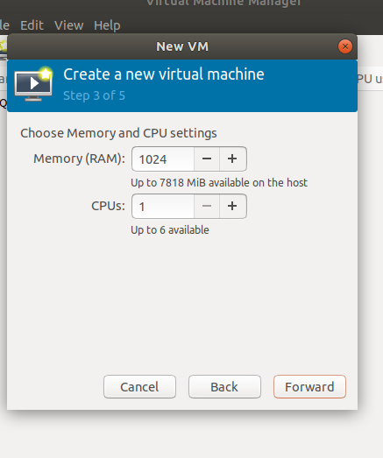

**Step 7:**  Allocate hard disk space to the VM. Click **Forward** to go to the last step.

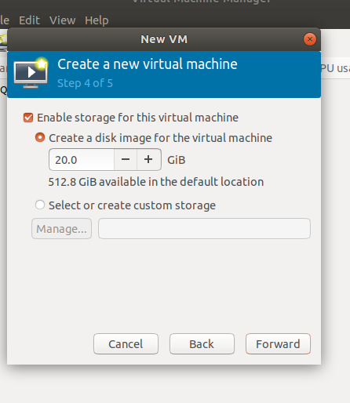

**Step 8:**  Specify the name for your VM and click **Finish** to complete the setup.

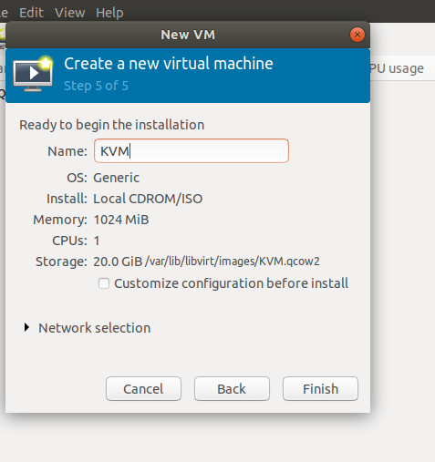

**Step 9:** Select language

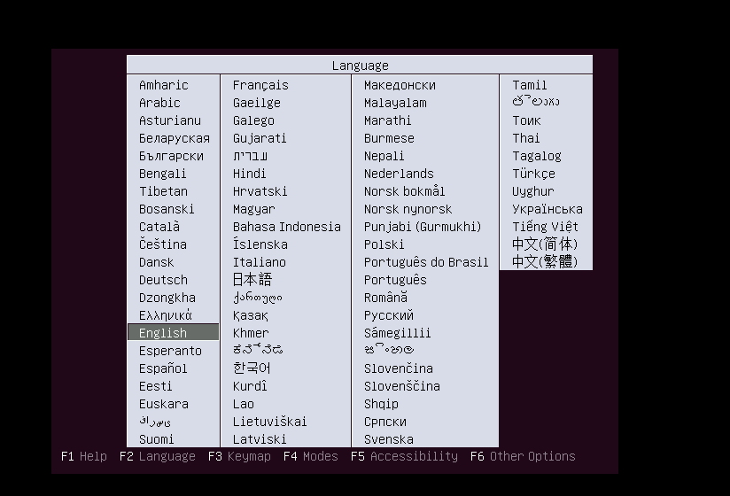

**Step 10:** The VM starts automatically, prompting you to start installing the OS that’s on the ISO file.

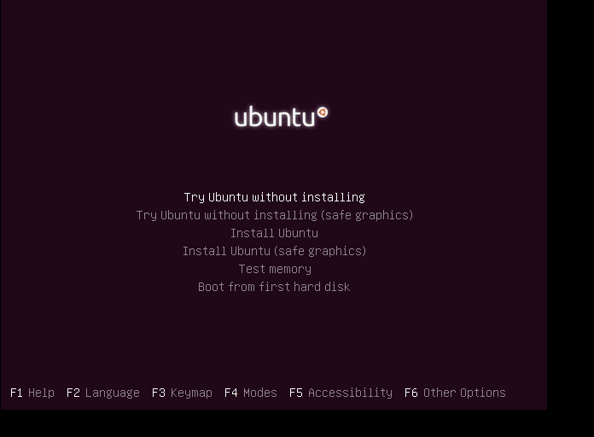

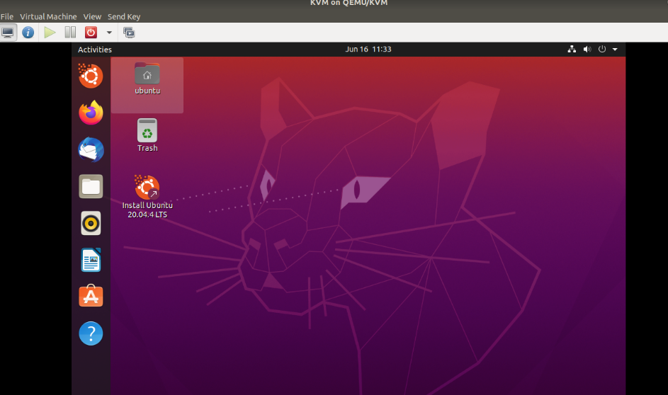

**Step 11:** Check the state of KVM

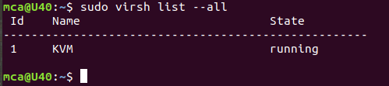

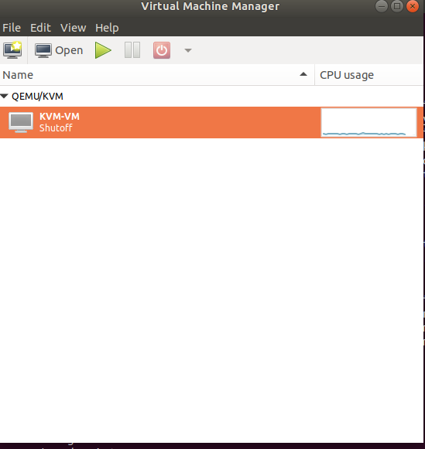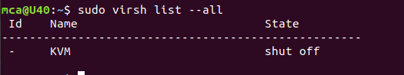

**NETWORKING & SYSTEM ADMINISTRATION LAB**



**Experiment No.: 19**

**Aim**

Docker Installation.

**Procedure**

**Step 1:**  Open the terminal on Ubuntu.

**Step 2:** Remove any docker files that are running in the system, using the following

command:

**$ sudo apt-get remove docker docker-engine docker.io**

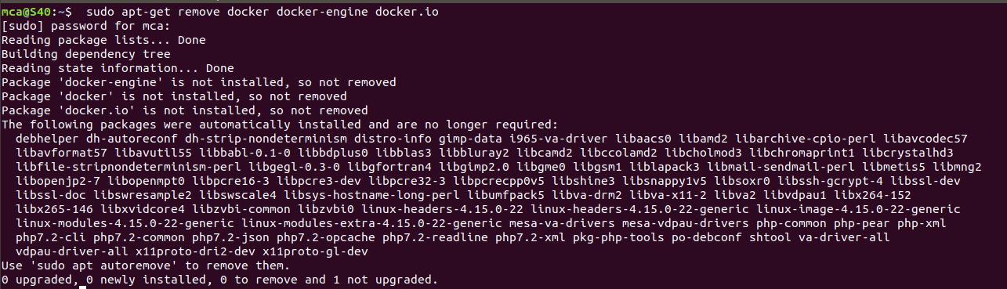

**Step 3:** Check if the system is up-to-date using the following command:

**$ sudo apt-get update**

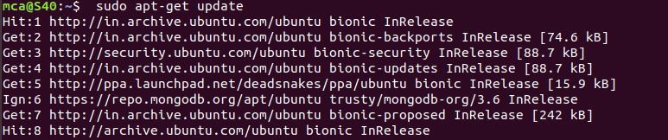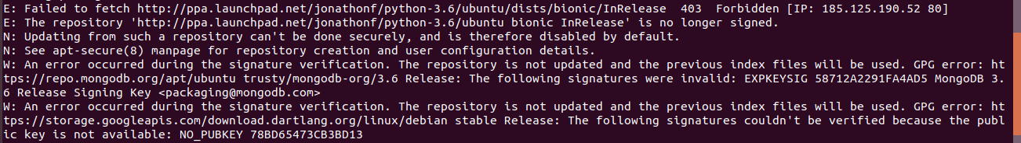

**Step 4:** Install Docker using the following command:

**$ sudo apt install docker.io**

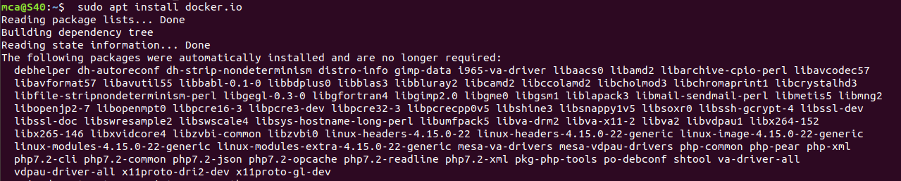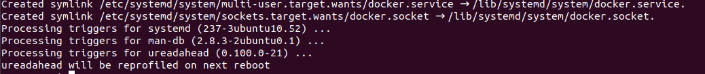

**Step 5:**  Install all the dependency packages using the following command:

**$ sudo snap install docker**



**Step 6:** Before testing Docker, check the version installed using the following command:

**$ docker –version**



**Step 7:** Pull an image from the Docker hub using the following command:

**$ sudo docker run hello-world**

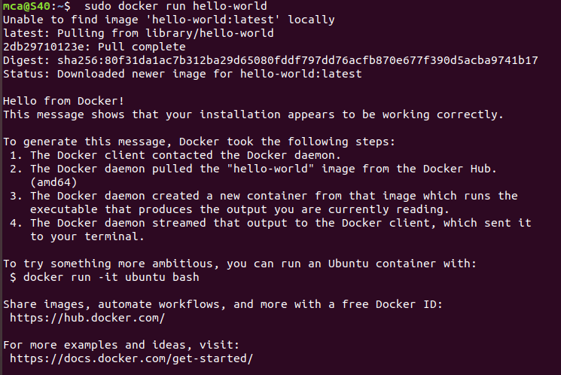

**Step 8:** Check if the docker image has been pulled and is present in your system using

the following command:

**$ sudo docker images**



**Step 9:** To display all the containers pulled, use the following command:

**$ sudo docker ps -a**



**Step 10:** To check for containers in a running state, use the following command:

**$ sudo docker ps**



**NETWORKING & SYSTEM ADMINISTRATION LAB**



**Experiment No.: 20**

**Aim**

## Setting Up an Apache Container

**Procedure**

**Step 1:** Pull Docker Apache Container

**$ sudo docker run -dit --name tecmint-web -p 8080:80 -v /home/user/website/:/usr/local/apache2/htdocs/ httpd:2.4**

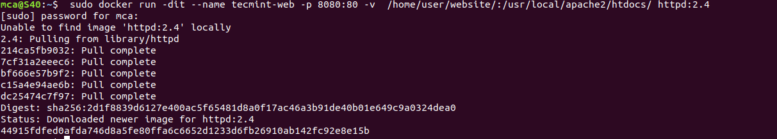

At this point, our Apache container should be up and running.

**Step 2:** Check Apache Docker Container.

**$ sudo docker ps**



Now let’s create a simple web page named docker.html inside the /home/user/website directory.

**Step 4:**

**$ sudo gedit /home/user/website/docker.html**

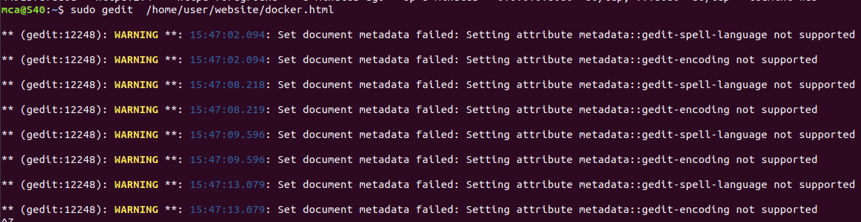

Add the following sample HTML content to the file.

<!DOCTYPE html>

<html lang="en">

<head>

<meta charset="UTF-8">

<title>Learn Docker at Tecmint.com</title>

</head>

<body>

<h1>Learn Docker With Us</h1>

</body>

</html>

Next, point your browser to Server-IP:8080/docker.html (where Server-IP is your host’s public IP address). You should be presented with the page we created previously.

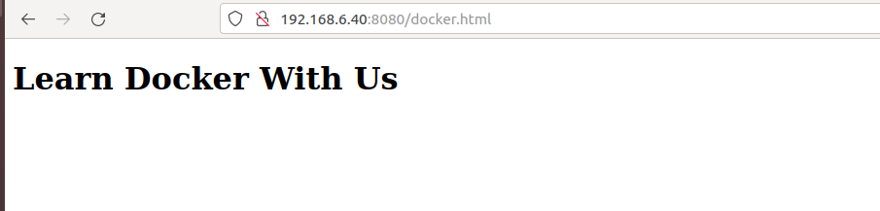

**Step 5:** If you wish, you can now stop the container.

**$ sudo docker stop tecmint-web**

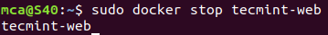

**Step 6:**  Remove it

**$ sudo docker rm tecmint-web**



**Step 7 :** To finish cleaning up, you may want to delete the image that was used in th container (omit this step if you’re planning on creating other Apache 2.4 containers soon).

**$ sudo docker image remove httpd:2.4**

